Market Access, Policies and Agricultural Transformation: Evidence Using Disaggregated Data from India

Digvijay S Negiª

Pratap S Birthal^{b}

Devesh Roy^{c}

Inter alia, agricultural transformation is considered an important pathway for sustainable improvements in agricultural productivity and agriculture-based livelihoods. In this paper, using highly spatially disaggregated data we study structural changes in Indian agriculture in terms of product diversification and commercialization in the presence of policy-induced market distortions. Indian agriculture is quite heterogeneous in topography, climatic conditions, crops and market access. We take this heterogeneity into consideration in our analysis by using data on cropping pattern for 4707 tehsils (the administrative units below district) from across the country; and by constructing a measure of market access based on distance of these tehsils from 494 major urban cities and their income levels. Our findings indicate that market access is critical in inducing diversification, more so on small farms, in favour of high-value cash crops such as vegetables and oilseeds that are perishable and require processing. Nonetheless, the policy-induced distortions in agri-food markets in the form of procurement of cereals, mainly rice and wheat, at government-determined minimum support prices discourage diversification even in the presence market access.

ª Assistant Professor, Indira Gandhi Institute of Development Research, Mumbai 400065, Maharashtra, India, digvijaynegi12@gmail.com, digvijay@igidr.ac.in.
^{b} National Professor, Indian Council of Agricultural Research, New Delhi 110012, India, ps.birthal@icar.gov.in.
^{c} Senior Research Fellow, International Food Policy Research Institute, Washington DC, USA, D.ROY@cgiar.org.

Market Access, Policies and Agricultural Transformation: Evidence Using Disaggregated Data from India

- Introduction

Owing to dominance of small landholdings and excessive employment pressure on agriculture, raising land and labor productivity remains one of the main policy concerns in developing countries as India. Inter alia, diversification of agriculture in favor of high-return, low-risk crops is considered an important pathway for sustainable improvements in agricultural productivity and agriculture-based livelihoods. Several studies have shown that diversification in favor of comparatively remunerative cash crops, food or non-food, in relation to the widely grown staple cereal crops improves land and labour productivity, enhances agricultural growth and contributes to poverty reduction (Jayne and Govereh 2003; Barghouti et al. 2004; Joshi, Birthal and Minot 2006; Birthal et al. 2014; Birthal, Roy and Negi 2015; Michler and Josephson 2017). Diversification further contributes to the resilience of agriculture to extreme climatic shocks such as droughts and heat-waves (Amare et al. 2018; Birthal and Hzarana 2019).

Structural transformation of economies is often preceded and triggered by diversification-led productivity growth and commercialization of agriculture (Johnston 1970; Gollin, Parente and Rogerson 2002; Foster and Rosenzweig 2004; Emran and Shilpi 2012; Bustos Caprettini and Ponticelli 2016). However, there are several barriers to product diversification in agriculture in developing countries. Literature identifies the lack of access to markets as one of the important impediments to diversification (Barrett 2007; Gulati et al. 2007; Hellin, Lundy and Meijer 2009; Shiferaw, Hellin and Muricho 2011). Poor transport infrastructure and asymmetric information cause significant market imperfections leading to high cost of trade and poor price realization by producers (de Janvry, Fafchamps and Sadoulet 1991; Kydd and Dorward 2004; Dorward et al. 2004; Meenakshi and Benerjee 2005; Poulton et al. 2005; Shiferaw, Hellin and Muricho 2011, Negi et al. 2018).

Markets apart, government policies may also create barrier to diversification. The developing countries as India, in their efforts to attain self-sufficiency in food, provide several price and non-price incentives to farmers for adoption of high-yielding improved bio-chemical technologies (seeds, fertilizers and agrochemicals). Many a times these incentives are not crop neutral, leading to distortions in cropping patterns, degradation of natural resources and increase income inequalities. For example, India, ever since the introduction of bio-chemical technologies in mid-1960s, has followed a cereal-centric price policy emphasizing on provision of markets and price incentives. To protect farmers (and also consumers) from significant fluctuations in market prices the government of India fixes minimum support prices (MSP) for several food and non-food crops, with an assurance of their procurement in case their market prices fall below the MSP. This policy, however, is effective in case of rice and wheat, the staple cereals that are procured in huge quantities by the government for public distribution system and buffer stocking. Such policy-induced distortions although have helped achieve self-sufficiency in cereals, these have also acted as disincentive to private investment in markets and associated infrastructures essential for agricultural diversification and commercialization (Rashid, Cummings and Gulati 2005; Gulati et al. 2007).
Economists have long recognized the importance of markets in product diversification in agriculture, yet there are only a few studies that have analysed this relationship at highly spatially disaggregated levels, the exception being Emran and Shilpi (2012) who utilized data from household survey in Nepal to understand the nuances of this relationship. In this paper, we use highly spatially disaggregated data to analyse structural changes in Indian agriculture in terms of product diversification and commercialization in the presence of policy-induced market distortions. In our analysis we consider several nuances of Indian agriculture. One, Indian agriculture is quite heterogeneous in topography, climatic conditions and crops; and we take this into consideration employing data on cropping activities for 4707 tehsils (an administrative unit below the district) spread throughout the country. And, accordingly we also construct a measure of market access based on the distance of tehsils from 494 urban cities, and their income levels. Two, Indian agriculture is dominated by smallholders, hence besides analysing the effect of market access on diversification for the overall sample we also estimate it by farm classes. Finally and more importantly, we introduce policy dimensions in our analysis to see how government interventions in agri-food markets influence land allocation decisions.
Our paper makes following contributions to the literature:

- Most studies that attempt to establish the causal impact of diversification on farm incomes, agricultural growth and rural poverty although recognize markets as one of the important channels behind the realized impacts, these rarely provide an empirical evidence on the linkages between markets and product diversification. Combining the granular gridded data on cropping pattern from the agricultural census and on indicators of market access from the population census, it provides estimates of the effects of market access on crop diversification. Importantly, we conceptualize market access to capture both the demand and supply sides of trade. Our measure takes into consideration the distance to the market center and the market size.

- Another issue that has not received much attention in the empirical literature relates to spatial dimension of cropping activities which besides the household or regional resource endowments are influenced by the markets too. In a frictionless economy with free flow of resources, commodities and services, each of the regional economies is expected to experience almost an equal change in acreage re-allocation in response to a change in market forces. It is, however, not; the potential for diversification of regions inter alia is influenced by market size and trade costs. We assess a location’s diversification potential by market size and trade costs conditional upon its natural resource endowments and agro-ecological conditions. This paper, for the first time, provides an empirical evidence on the relationship between crop diversification and market access at a highly spatially disaggregated level (tehsil i.e. sub-district) combining data from multiple sources.

- Finally, it shows that how policy distortions in agri-food markets influence farmers land allocation decisions even with better market access.

The main challenge in estimating causal impact of market access on crop diversification emanates from the problem of endogeneity as crop choices and farmer specific market access are jointly determined. To address this, we apply Lewbel’ heteroskedasticity based estimator that relaxes the stringent exclusion restriction of the traditional IV-2SLS estimator. Lewbel (2012) shows that identification can be achieved without exclusion restriction in the presence of exogenous variables in the structural equation and heteroskedasticity in the error terms.

Rest of the paper is organized as follows. Section 2 describes in detail multiple datasets that we have combined to construct measures of diversification and market access and other relevant variables, and section 3 discusses the construction of the measure of market access. Summary statistics of key variables is presented in section 4. Section 5 describes the empirical strategy to estimate the relationship among product diversification, market access and price policy. Section 6 presents the results and it is followed by a discussion of key findings in section 7. The final section presents concluding remarks.

- Data

Most studies that examine the relationship between market access and crop diversification use either highly spatially disaggregated household or village level data (e.g., Emran and Shilpi 2012 ) or spatially aggregated state or district level data (e.g., Joshi et al. 2004; Rao et al. 2006). The household-level analysis although comprehensive in capturing several nuances of the local farming systems (that otherwise are difficult to capture at higher levels of spatial aggregation), the sample size is often small to draw conclusions for policy actions. Besides, it is possible that even with equal market access some households in a village or some villages may follow a highly specialized cropping pattern. The other line of research that relies on spatially aggregated data usually has low granularity and cannot unpack the heterogeneity in cropping pattern and market channels available at lower geographical as well as administrative levels. We consider tehsil or sub-district to represent an intermediate level of spatial aggregation to reveal true level of crop diversification. To the best of our knowledge, no study has used datasets at this level of spatial disaggregation to understand product diversification and commercialization in Indian agriculture.
In our analysis we make use of data from three different sources:

- Agricultural census: data on crop acreage

The Ministry of Agriculture and Farmers’ Welfare, Government of India conducts a quinquennial census of agricultural activities focusing on size distribution of landholdings (owned and operational), acreage allocations and irrigation status by crop. This is the only source of data on cropping pattern, aggregated at the level of a tehsil, district and state.

We use data from the latest available agricultural census 2011-12. Although this dataset is in the public domain (https://agcensus.nic.in), the format in which it is provided is not user-friendly. It took considerable time and efforts of ours in downloading the data for each tehsil, their compilation and processing for final use. Our final variables include area allocation to different crops or group of similar crops by farm size for each of the 5135 tehsils in 517 districts of 20 states in the country. We believe that ours is the first ever analysis that utilizes tehsil-level information on cropping patterns.

From data on area allocation to crops or groups of similar crops we construct Simpson index of diversification:

${Crop diversity index}_{i}=\left(1-\sum_{i=1}^{C}{P_{i}^{2}}\right)×100$ (1)

where, P_{i} is proportion of the total cropped under crop i. This index is bounded between 0 and 1; 0 implying complete specialization and 1 complete diversification. The index, however, provides only the extent of diversity and not the types of crops grown. Hence, in our econometric analysis, besides diversification index, we also consider proportions of the total cropped area allocated to different crops or crop groups as alternate measures of diversification. The crop groups include: cereals (rice, wheat, millets, maize and sorghum), pulses (chickpea, piegonpea and other minor pulses), oilseeds and fibers (rapeseed and mustard, groundnut, other oilseeds and cotton), sugarcane, vegetables, and horticulture (fruits and plantations).

- Population census: village amenities data

The agricultural census although rich in information on land use, it does not provide information on markets, infrastructure and institutions that matter in land allocation decisions. For such variables, we rely on village amenities database from the population census which is conducted at a decadal interval by the Ministry of Human Resource Development, Government of India. Incidentally, the latest population census also pertains to 2011 which is also the reference year for agricultural census. Besides demographic information, this database also contains information on infrastructures and other amenities in the villages. Again, this is a uniquely comprehensive source of data on general amenities and infrastructure at village level, which has rarely been utilized in economic analysis.

Most variables in the village database are binary and indicate just the availability of amenities in a village. We aggregate village-level variables of our interest at the level of a tehsil, which is our unit of observation, using village population as weight. Subsequently, we identify tehsils common in agricultural census and population census. We could accurately identify 4707 or 92% of the tehsils that are common in both the data sets. Since the infrastructure and other variables are weighted by village population, these essentially reflect proportion of the population in a tehsil exposed to these amenities.

- Gridded data: natural endowments and market size

For data on natural endowments we rely on the gridded data from the Food and Agriculture Organization Global Agro-Ecological Zones (FAO-GAEZ) project. This database includes several indicators of crop suitability. The FAO-GAEZ database provides gridded data for each grid point of 100 square kilometres, and assigns each grid cell a score ranging from 0 for soils unsuitable for cultivation of a specific crop to 7 for soils highly suitable for the crop. From this database, we also extract data on temperature, rainfall, slope and altitude besides the crop suitability indices for each tehsil that serve as controls in our econometric analysis.

To construct an appropriate measure of market access we need data on its twin indicators, i.e., the distance to urban/market centres and their market size or effective demand for food and non-food commodities. From the population census we identified 494 cities with a population of more than 100 thousand. The population itself can serve as proxy for market size, but the more appropriate measure is the income of the urban centre. The income or gross domestic production for tehsils is not estimated by the government(s). For this we rely on Ghosh et al. (2010) who generated spatially disaggregated one square kilometre maps of the total economic activity using the night time lights satellite imagery and LandScan population grids. From this gridded dataset we estimate gross domestic product for all the 494 cities. A few studies have used the night light data to estimate income and poverty levels at state or district level, but to the best of our knowledge there is hardly any study, except by Gibson et al. (2017) that has used night time light data to generate estimates of incomes for major cities of India.

- Constructing a measure of market access

The main challenge for construction of an effective measure of market access is to identify indicators that can capturing both demand and supply side of trade. From an extensive review of empirical studies, Chamberlin and Jayne (2013) identify a number of indicators of market access that include distance to the nearest wholesale or retail market, town and service centre; travel time; transportation costs; mode of transportation; presence of road in a location; quality of road (all-weather, metaled or un-metaled) and road density. Further, they observed that most studies have used a single indicator of market access. In this context, Wood (2007) argues that “indicators are typically selected on an ad hoc basis, with indicator choice varying widely across studies and rarely discussed in terms of specific marketing channels, explicit transactions costs, or price formation processes”.

Along with the physical distance indicators, the market size, measured in terms of urban population or income, is also an important indicator of market access (Joshi et al. 2004; Emran and Shilpi 2012) that influences the patterns of agricultural diversification or specialization via demands for different agricultural commodities. Both the physical distance and market size are complementary measures of market access. According to Von Thunen (1986) theory of agricultural specialization the inertia generated by a major economic centre influences agricultural land use around the center in a manner that a pattern of rings of specialization develop around that center. The ring closest to the center tends to specialize in perishable commodities, such as vegetables and milk that are high in demand in urban centers. As the distance from urban center increases the subsequent rings specialize in production of less perishable commodities like cereals and pulses.

Von Thunen model considers distance from a single urban centre as a measure of market access. In reality, there are multiple cities and towns that surround a production region, and each urban center based on its economic mass influences the land use in nearby regions. Thus, there is a possibility of overlapping of the rings of specialization. We rely on gravity equation of international trade to construct our measure of market access (for details see, Emran and Shilpi 2012), which suggests that trade between two regions is directly proportional to the economic mass of the regions but is inversely related to the distance between them. Intuitively, a larger urban center (in income terms) would have a larger influence on the economic activity of the trading partners. Further, for given economic mass of a urban center, as the distance between a production region and urban center increases the cost of transportation also increases, attenuating the effect of urbanization on economic activities of the region.

We write our measure of market access as:

${Market Access}_{i}=\frac{1}{K}\sum_{k=1}^{K}{\frac{m_{ik}}{d_{ik}^{2}}}$ (2)
where, $m_{ik}$ denotes size of the urban center i , measured by its gross domestic product. $d_{ik}$is the linear distance between tehsil and k^{th} urban center and K is the total number of urban centers. We calculate Euclidian distance between the GPS coordinates of a tehsil center and of the geo-coded urban centers. This is repeated for each tehsil 494 times. To assess the degree of market access, we take inverse of the squared distance and then calculate the weighted average of all 494 inverse squared distances with gross domestic product of the urban center as weight. The squared distance gives more weight to the urban centers located at shorter distances. This measure of market access is positively related to the economic mass of urban center and is inversely proportion to the distance between urban center and tehsil.

- Descriptive statistics

Figure 1 shows density plots of the index of crop diversification. There is considerable variation in crop diversification across tehsils. Cereals occupy the largest share of total cropped area, followed by oilseeds (including fibers) and pulses (Table 1). Expectedly, cereals have the least spatial variation in their area share, and cash crops including vegetables, horticulture and sugarcane have relatively a higher spatial spread.

Figure 1. Distribution of crop diversification
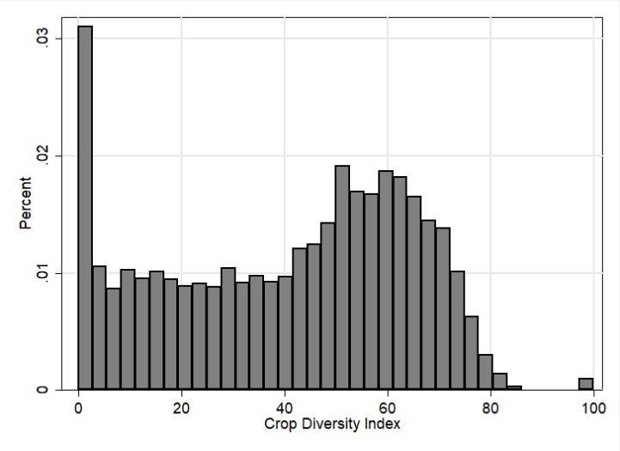

Table 1. Summary statistics
 | Source | Mean | SD | CV | Min | Max | N
Dependent variables
Crop diversity index | Agricultural census 2011 | 40.5 | 23.7 | 0.6 | 0.0 | 100.0 | 4127
Percent area under cereals | Agricultural census 2011 | 60.0 | 31.1 | 0.5 | 0.0 | 100.0 | 4127
Percent area under pulses | Agricultural census 2011 | 9.5 | 14.6 | 1.5 | 0.0 | 100.0 | 4127
Percent area under sugarcane | Agricultural census 2011 | 2.3 | 7.5 | 3.2 | 0.0 | 97.5 | 4127
Percent area under oilseeds and fibres | Agricultural census 2011 | 18.1 | 24.1 | 1.3 | 0.0 | 100.0 | 4127
Percent area under vegetables | Agricultural census 2011 | 2.8 | 7.5 | 2.7 | 0.0 | 81.3 | 4127
Percent area under horticulture crops | Agricultural census 2011 | 7.3 | 14.1 | 1.9 | 0.0 | 100.0 | 4127
Market access index | Census 2011 | 0.2 | 3.0 | 13.4 | 0.01 | 207.0 | 4127
Control variables
Percent area under irrigation | Census 2011 | 43.3 | 30.5 | 0.7 | 0.0 | 126.4 | 4127
Percent villages with electricity | Census 2011 | 71.1 | 36.4 | 0.5 | 0.0 | 100.0 | 4127
Number of schools per person | Census 2011 | 2.2 | 1.2 | 0.5 | 0.3 | 20.2 | 4127
Number of hospitals per person | Census 2011 | 0.4 | 0.4 | 1.0 | 0.0 | 11.2 | 4127
Percent villages with a post office | Census 2011 | 26.7 | 23.5 | 0.9 | 0.0 | 100.0 | 4127
Percent villages with a railway station | Census 2011 | 4.5 | 8.1 | 1.8 | 0.0 | 100.0 | 4127
Percent villages with tractors | Census 2011 | 60.0 | 36.5 | 0.6 | 0.0 | 100.0 | 4127
Percent villages with telephone line | Census 2011 | 70.4 | 31.9 | 0.5 | 0.0 | 100.0 | 4127
Percent villages with a bank | Census 2011 | 19.1 | 15.9 | 0.8 | 0.0 | 100.0 | 4127
Altitude (meters) | FAO-GAEZ | 362.0 | 542.1 | 1.5 | 0.0 | 5058.2 | 4127
Slope index | FAO-GAEZ | 3.5 | 1.6 | 0.4 | 0.0 | 9.0 | 4127
Temperature ^{ο}C | FAO-GAEZ | 25.5 | 3.0 | 0.1 | -4.4 | 29.3 | 4127
Rainfall (mm) | FAO-GAEZ | 1282.0 | 590.4 | 0.5 | 167.3 | 4398.2 | 4127
Agricultural suitability index | FAO-GAEZ | 34.8 | 14.8 | 0.4 | 0.0 | 71.8 | 4127

Table 2 presents correlation matrix of the index of diversification, area shares of crops and market access. Area share of cereals has a negative correlation with the index of crop diversification, and also with area shares of other crops. This suggests that cereals compete for land with non-cereal crop food as well as non-food crops. Overall, we observe cereal-based cropping system less diversified. On the other hand, the diversification index has a positive correlation with area shares of pulses and oilseeds including fibers. Pulses, oilseeds including fibers are cultivated largely in rainfed regions. Diversification index is also positively associated with area share of vegetables and horticultural crops.

Table 2. Correlation matrix
 | Cereals | Pulses | Sugarcane | Oilseeds-  fibres | Vegetables | Horticulture | Index of  diversity | Index of  market  access
Cereals | 1
Pulses | -0.404*** | 1
Sugarcane | -0.147*** | -0.073*** | 1
Oilseeds-  fibres | -0.715*** | 0.002 | -0.080*** | 1
Vegetables | -0.172*** | -0.058*** | 0.010 | -0.092*** | 1
Horticulture | -0.394*** | -0.080*** | -0.003 | -0.045*** | 0.061*** | 1
Index of  diversity | -0.743*** | 0.346*** | 0.185*** | 0.420*** | 0.194*** | 0.360*** | 1
Index of  market access | -0.017 | -0.007 | 0.010 | 0.004 | 0.067*** | -0.002 | 0.032** | 1
***, **, and * indicate statistical significance at the 1%, 5%, and 10% levels, respectively.

Figures 2 and 3 respectively show geocoded locations of major urban centers in India and variation in market access. The darker shades in figure 3 denote greater market access. On juxtaposition of figure 2 with figure 3 we clearly notice that the regions with higher density of urban centers also have a better access to markets.

Figure 2. Location of cities in India with population of at least one lakh persons
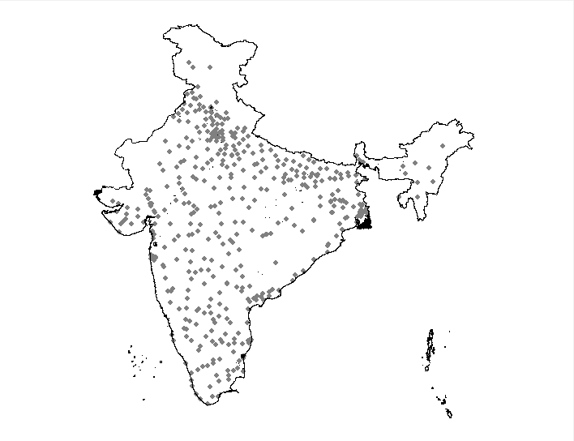

Figure 3. Market access based on distance to major cities
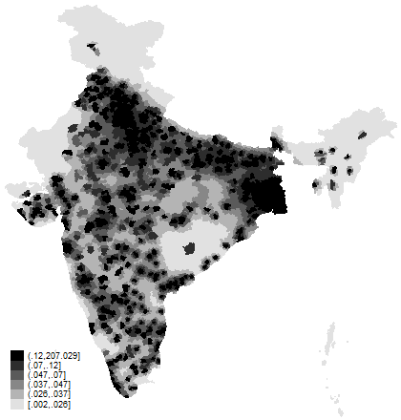

- Empirical strategy

Let’s consider the following to quantify the relationship between product diversification in agriculture and market access:

$$Y_{ij}=α_{j}+δ{Market Access}_{ij}+X_{ij}β+ε_{ij} (3)$$

where, Y_{ij} represents diversification, as an index or the proportion of the total cropped area under a crop in tehsil i of state j. In this equation, we include state fixed effects as to control for the unobserved differences in infrastructure, institutions, policies and governance structures across states. X is vector of explanatory variables that include electricity, irrigation and machines, telephones, banks, schools and hospitals. Electricity, irrigation, and banks directly influence cropping activities, while schools and hospitals reflect availability of social infrastructure or status of socio economic development. It is conjectured that farmers in a region with higher level of social infrastructure are better informed and motivated to diversify their production portfolio (Birthal, Negi and Roy 2017). Another important set of controls that we include is the natural endowments that not only influence cropping pattern but also determine location of a market. For instance, an urban center might have historically come up in a region because of its natural endowments that are suitable for production of diverse crops. Omission of natural endowments thus can bias the estimates of market access. We use crop-specific suitability indices from FAO-GAEZ and construct average agricultural suitability index for each tehsil. We also control for topography and climatic conditions by including rainfall, temperature, slope and altitude of tehsils.

Further, we assess the relationship between market access and crop diversification by farm size, and modify equation (3) as:

$$Y_{lij}=α_{j}+\sum_{l}{γ^{l}{Land Class}_{ij}^{l}}+\sum_{l}{δ^{l}}{Land Class}_{ij}^{l}×{Market Access}_{ij}+X_{ij}β+ε_{ij} (4)$$

where, $Y_{lij}$ is crop diversification on ${Land Class}^{l}$ in in tehsil i of state j. Land class is a dummy variable equaling one for land class l, and zero otherwise. The land classes are defined as marginal (less than or equal to one ha), small (1-2ha), medium (2-4 ha) and large (more than 4 ha). In our analysis, we keep marginal class as base, and therefore $γ^{l}$ provides difference in the extent of diversification on a farm class in relation to the marginal farm class. Further, we interact index of market access with each fam class. The coefficient of interest is $δ^{l}$ that captures the effect of market access on diversification for a farm class.

Initially, we had hypothesized that access to markets induces structural transformation in agriculture. However, the policy-induced market distortions, such as the procurement of rice and wheat in large quantities by the government at pre-determined prices, may influence pattern of diversification even in the presence of an effective market access. To test this, we modify equation (3) to include an interaction of market access with proportion of rice and wheat procured by the government in state j:

$$Y_{ij}=α_{j}+δ{Market Access}_{ij}+δ^{p}{Procurement}_{j}×{Market Access}_{ij}+X_{ij}β+ε_{ij} (5)$$

The state-level procurement term is absorbed in the state fixed effects. The marginal effect of market access on the diversification index or area share of crops then can be estimated as:
$$\frac{∂Y_{ij}}{∂{Market Access}_{ij}}=δ+δ^{p}{Procurement}_{j} (6)$$
The relationship between market access and diversification is now determined by state level procurement of rice and wheat. Since use the combined procurement of rice and wheat at state level in our equation, this variable is exogenous to cropping decisions at tehsil level.

Our coefficient of interest in equation (6) is $δ$. Even with all controls in vector X, $δ$ may not capture the true effect of market access on diversification because of the omitted variables that are endogenous with crop diversification. If the error term $ε$ in equation (3) is composed of omitted variables $v$ and measurement error $ϵ$ in the outcome variable, i.e., $ε_{i}=v_{i}+ϵ_{i}$, then we require an instrument for market access that can overcome the problem of possible endogeneity and measurement error bias.

Consider Z as a vector of exogenous variables, i.e., $Z⊆X$, then an ideal conventional instrument must satisfy the following conditions:

- Relevance condition: The instrument should be correlated with the market access, i.e., $Cov(Z_{i},{Market Access}_{i})≠0$.
- Exclusion restriction: The instrument should influence the outcome variable only through market access, i.e., it should not be correlated with the omitted variables, i.e., $Cov\left(Z_{i},v_{i}\right)=0.$

Finding an instrumental variable that satisfies these conditions, however, is not easy. Topographical features as the altitude and slope could serve as instruments because these are possibly exogenous to a household’s decision problem, but these may not satisfy the exclusion restriction because of their possible correlation with the omitted variables. We, therefore, implement Lewbel’s two-step estimator where identification is achieved without exclusion restriction (Lewbel 2012). Several other studies, for example Emran and Shilpi (2012), Gao and Smyth (2015), Mishra and Smyth (2015), Lin, Weldemicael and Wang (2017) and Emran and Hou (2013) have relied on this identification strategy. Below we discuss in brief assumptions for identification and the procedure to implement Lewbel’s estimator (for details, see Lewbel 2012). This approach replaces exclusion restriction with two additional restrictions.

Consider the following equation:

$${Market Access}_{ij}=τ_{j}+ϕZ_{ij}+ω_{ij} (4)$$

For identification, the Lewbel two-step estimator relies on the following conditions:

- $Cov\left(Z_{i},ε_{i}ω_{i}\right)=0;i.e.,$ the variables in vector Z should be uncorrelated with the product of error terms in equation (3) and equation (4).

- $Cov\left(Z_{i},ω_{i}^{2}\right)≠0$; i.e., the variables in vector Z must be correlated with squared residuals of equation (4). For this condition to be satisfied, $E\left(ω_{i}^{2}\right)$ should not be a constant, hence there should be heteroskedasticity in error terms in equation (3).

Lewbel (2012) shows that if the above conditions are met we can construct an instrument as product of the de-meaned exogenous variables in vector Z and the estimated errors from equation (3). Let ${\hat{Z}}_{i}$ be a vector of the constructed instruments, then ${\tilde{Z}}_{i}=\left(Z_{i}-{\overline{Z}}_{i}\right){\hat{ω}}_{i}$ , where ${\hat{ω}}_{i}$ are the estimated residuals from equation(3). The first stage equation then can be specified as:

$${Market Access}_{ij}=ρ_{j}+σ{\tilde{Z}}_{ij}+ξ_{ij} (5)$$

As in the case of a conventional instrumental variable strategy, Lewbel’s approach also requires a set of controls to be exogenous. For this, an essential requirement is the heteroskedasticity in residuals of equation (4). We formally test for the heteroskedasticity using White’s general test (White, 1980). We implement Lewbel’s strategy employing two-step efficient generalized method of moments (GMM) estimator as it provides efficiency gains over the traditional IV/2SLS estimator. For an exactly identified model, the efficient GMM and traditional IV/2SLS estimators are same, and on the assumptions of conditional homoskedasticity and independence, the efficient GMM estimator is same as traditional IV/2SLS estimator.

In our specifications we have included a rich set of controls for agro-climatic conditions derived from FAO-GAEZ database. With extensive controls, akin to Emran and Shilpi (2012), it is unlikely that residual common agro-climatic factors could drive the pattern of heteroscedasticity in market size. Alternatively, to expect that variations in second moment of market size due to agricultural suitability would be correlated with the pattern of specialization and commercialization in a given location is not plausible. The variation in market size in such a situation, as Emran and Shilpi (2012) suggest, could be taken as a quasi-random assignment of treatment to the relevant location.

- Results

  - Market access and diversification

We begin by a discussion on linear estimates of equation (3). Coefficient on market access is positive and statistically significant (Table 3), indicating that crop diversification is prominent in regions with better market access. The effect of market access on individual crops or crop groups, however, are heterogenous. It is positive and statistically significant in case of oilseeds (including fibers) and vegetables; negative and significant in case of horticulture (fruits and plantations), and not significant in case of cereals and pulses.

Table 3. Market access, crop diversity and cropping patterns: linear fixed effects model
 | (1) | (2) | (3) | (4) | (5) | (6) | (7)
 | Index of  diversification | Cereals | Pulses | Sugar crops | Oilseeds-fibre | Vegetables | Horticulture
Market access | 1.064** | -0.776* | 0.174 | 0.008 | 0.483* | 0.362** | -0.251*
 | (0.445) | (0.463) | (0.290) | (0.094) | (0.260) | (0.163) | (0.152)
Irrigation | -0.091*** | 0.299*** | -0.121*** | 0.047*** | -0.186*** | 0.005 | -0.044*
 | (0.031) | (0.040) | (0.025) | (0.011) | (0.043) | (0.008) | (0.026)
Electricity | 0.065*** | -0.084*** | 0.019 | 0.007 | 0.046** | 0.004 | 0.008
 | (0.021) | (0.024) | (0.013) | (0.008) | (0.019) | (0.007) | (0.015)
School | -1.270** | -0.681 | -0.207 | -1.062*** | 0.530 | 0.674 | 0.746
 | (0.596) | (1.000) | (0.357) | (0.293) | (0.660) | (0.538) | (0.567)
Hospital | -1.660 | 3.410* | -0.106 | 0.245 | -3.843** | -0.046 | 0.340
 | (1.213) | (1.767) | (0.563) | (0.466) | (1.753) | (0.445) | (0.981)
Post office | -0.033 | -0.066 | 0.009 | -0.007 | 0.079 | -0.018*** | 0.004
 | (0.039) | (0.045) | (0.022) | (0.010) | (0.056) | (0.006) | (0.028)
Railway station | -0.009 | -0.031 | -0.007 | -0.043*** | 0.059 | 0.000 | 0.022
 | (0.053) | (0.062) | (0.027) | (0.015) | (0.049) | (0.013) | (0.036)
Tractor | 0.012 | -0.007 | -0.015 | 0.011 | 0.002 | 0.005 | 0.005
 | (0.019) | (0.023) | (0.015) | (0.007) | (0.022) | (0.006) | (0.013)
Telephone | 0.064*** | -0.065* | 0.001 | 0.003 | 0.012 | 0.016** | 0.034*
 | (0.021) | (0.036) | (0.016) | (0.009) | (0.047) | (0.007) | (0.019)
Bank | -0.007 | -0.028 | 0.014 | 0.028* | -0.078** | 0.016 | 0.047
 | (0.036) | (0.041) | (0.028) | (0.016) | (0.035) | (0.011) | (0.031)
Altitude | -0.000 | -0.010 | 0.011* | 0.002 | 0.015 | 0.004** | -0.021***
 | (0.007) | (0.009) | (0.006) | (0.003) | (0.010) | (0.002) | (0.006)
Slope | 1.597*** | -1.538** | -1.127** | 0.374 | 0.053 | -0.045 | 2.283***
 | (0.553) | (0.734) | (0.440) | (0.261) | (0.625) | (0.195) | (0.519)
Temperature | -1.072 | -0.802 | 2.190** | 0.262 | 2.460 | 0.029 | -4.139***
 | (1.175) | (1.632) | (1.072) | (0.572) | (1.697) | (0.312) | (1.079)
Rainfall (mm) | -0.005** | 0.006** | -0.003** | 0.003** | -0.012*** | 0.001 | 0.005*
 | (0.002) | (0.003) | (0.001) | (0.001) | (0.003) | (0.001) | (0.003)
Agricultural suitability | -0.086** | 0.266*** | -0.184*** | 0.003 | -0.001 | -0.001 | -0.084**
 | (0.042) | (0.061) | (0.035) | (0.016) | (0.047) | (0.015) | (0.034)
N | 4127 | 4127 | 4127 | 4127 | 4127 | 4127.000 | 4127.000
R² | 0.408 | 0.470 | 0.180 | 0.137 | 0.371 | 0.118 | 0.254
Notes: All regressions include state fixed effects. Figures in parenthesis are standard errors robust to intra-district correlation of residuals. ***, **, and * indicate statistical significance at the 1%, 5%, and 10% levels, respectively.

Both the diversification index and the area shares of crops are bound between 0 and 1; hence there is a possibility of these being clustered at lower or upper bound or both. Thus, a linear specification is likely to yield biased estimates. We, therefore, estimate a Tobit version of equation (3) that adjusts for bias in estimates. Tobit estimates are quite similar to the linear estimates, that means that linear specification of equation (3) is not a much cause of concern for our data-set.

Table 4. Market access, crop diversity and cropping patterns: Tobit model
 | (1) | (2) | (3) | (4) | (5) | (6) | (7)
 | Crop  diversity | Cereals | Pulses | Sugar  Crops | Oilseed-Fibre  Crops | Vegetables | Plantation  Crops
Market access | 1.061** | -0.743 | 0.085 | -0.019 | 0.523* | 0.378** | -0.297*
 | (0.447) | (0.462) | (0.368) | (0.207) | (0.283) | (0.179) | (0.167)
Irrigation | -0.092*** | 0.302*** | -0.133*** | 0.098*** | -0.215*** | 0.004 | -0.053*
 | (0.032) | (0.041) | (0.028) | (0.020) | (0.048) | (0.010) | (0.030)
Electricity | 0.069*** | -0.088*** | 0.026 | 0.008 | 0.054** | 0.010 | 0.001
 | (0.021) | (0.026) | (0.016) | (0.015) | (0.022) | (0.010) | (0.019)
School | -1.259** | -0.687 | -0.279 | -1.961*** | 0.644 | 0.663 | 0.649
 | (0.600) | (1.002) | (0.407) | (0.661) | (0.738) | (0.564) | (0.625)
Hospital | -1.721 | 3.526* | -0.272 | -0.609 | -4.445** | 0.032 | 0.373
 | (1.241) | (1.814) | (0.645) | (1.331) | (2.082) | (0.489) | (1.009)
Post office | -0.034 | -0.067 | 0.010 | -0.031 | 0.083 | -0.022** | 0.009
 | (0.039) | (0.045) | (0.025) | (0.025) | (0.059) | (0.010) | (0.033)
Railway station | -0.013 | -0.018 | -0.005 | -0.091*** | 0.028 | 0.015 | 0.043
 | (0.057) | (0.066) | (0.034) | (0.033) | (0.057) | (0.019) | (0.045)
Tractor | 0.009 | -0.004 | -0.024 | 0.017 | 0.006 | 0.005 | 0.006
 | (0.019) | (0.023) | (0.017) | (0.012) | (0.025) | (0.008) | (0.015)
Telephone | 0.063*** | -0.063* | -0.006 | 0.027 | 0.015 | 0.024** | 0.060**
 | (0.022) | (0.037) | (0.019) | (0.020) | (0.051) | (0.011) | (0.027)
Bank | -0.010 | -0.024 | 0.000 | 0.048* | -0.095** | 0.021 | 0.050
 | (0.037) | (0.042) | (0.033) | (0.029) | (0.039) | (0.015) | (0.035)
Altitude | 0.001 | -0.012 | 0.014** | 0.003 | 0.016 | 0.006** | -0.025***
 | (0.007) | (0.009) | (0.007) | (0.006) | (0.010) | (0.002) | (0.007)
Slope | 1.583*** | -1.562** | -1.149** | 1.037** | 0.086 | 0.135 | 2.684***
 | (0.562) | (0.744) | (0.508) | (0.497) | (0.695) | (0.246) | (0.619)
Temperature | -0.829 | -1.091 | 2.926** | 0.444 | 3.018* | 0.249 | -4.829***
 | (1.208) | (1.664) | (1.249) | (1.037) | (1.824) | (0.414) | (1.260)
Rainfall (mm) | -0.004** | 0.006** | -0.003** | 0.003* | -0.012*** | 0.000 | 0.005*
 | (0.002) | (0.003) | (0.002) | (0.002) | (0.003) | (0.001) | (0.003)
Crop suitability | -0.087** | 0.267*** | -0.185*** | 0.011 | 0.008 | 0.005 | -0.091**
 | (0.043) | (0.062) | (0.037) | (0.029) | (0.049) | (0.018) | (0.038)
N | 4127 | 4127 | 4127 | 4127 | 4127 | 4127 | 4127
Notes: All regressions include state fixed effects. Figures in parenthesis are standard errors robust to intra-district correlation of residuals. ***, **, and * indicate statistical significance at the 1%, 5%, and 10% levels, respectively.

The estimated effects of market access on crop diversification reported in Tables 3 and 4 are indicative and cannot be interpreted as causal because the endogeneity of market access. To resolve this, we estimate Lewbel’s two-step GMM estimator with higher moment instruments. The results are presented in Table 5. White’s $χ^{2}$ statistic is sufficiently large to reject the null hypothesis of homoscedastic error term $ω_{ij}$ in equation (3), hence our specification satisfies condition (ii) of Lewbel approach.

Table 5. Market access, crop diversity and cropping patterns: Lewbel two-step estimator
 | (1) | (2) | (3) | (4) | (5) | (6) | (7)
 | Index of diversification | Cereals | Pulses | Sugar  crops | Oilseeds-fibres | Vegetables | Horticulture
Market access | 1.057*** | -0.567*** | 0.097 | -0.107*** | 0.770*** | 0.260*** | -0.093
 | (0.211) | (0.148) | (0.179) | (0.022) | (0.128) | (0.051) | (0.110)
Irrigation | -0.121*** | 0.349*** | -0.076*** | 0.027*** | -0.186*** | -0.008* | -0.001
 | (0.015) | (0.018) | (0.010) | (0.004) | (0.014) | (0.004) | (0.010)
Electricity | 0.066*** | -0.099*** | 0.013 | 0.001 | 0.054*** | 0.000 | -0.010
 | (0.015) | (0.017) | (0.008) | (0.004) | (0.012) | (0.005) | (0.007)
School | -1.087*** | 0.697 | -0.632** | -0.616*** | 0.612* | -0.183 | 1.198***
 | (0.389) | (0.598) | (0.260) | (0.122) | (0.366) | (0.214) | (0.353)
Hospital | -1.991** | 3.972*** | -0.162 | -0.055 | -5.153*** | -0.325 | -0.270
 | (0.877) | (1.113) | (0.373) | (0.171) | (0.925) | (0.376) | (0.677)
Post office | -0.030* | -0.073*** | 0.016 | -0.009** | 0.087*** | -0.012** | -0.004
 | (0.018) | (0.022) | (0.013) | (0.004) | (0.020) | (0.005) | (0.013)
Railway station | -0.011 | -0.027 | 0.010 | -0.033*** | 0.038 | -0.017 | 0.054*
 | (0.043) | (0.050) | (0.026) | (0.010) | (0.043) | (0.013) | (0.028)
Tractor | 0.007 | -0.005 | -0.008 | 0.004 | 0.026* | 0.003 | -0.015
 | (0.015) | (0.018) | (0.010) | (0.004) | (0.016) | (0.005) | (0.010)
Telephone | 0.056*** | -0.046** | 0.007 | -0.003 | -0.012 | 0.013** | 0.036***
 | (0.018) | (0.021) | (0.011) | (0.006) | (0.018) | (0.006) | (0.010)
Bank | 0.000 | -0.048 | 0.007 | 0.015* | -0.088*** | 0.004 | 0.019
 | (0.028) | (0.033) | (0.021) | (0.009) | (0.029) | (0.009) | (0.020)
N | 4127 | 4127 | 4127 | 4127 | 4127 | 4127 | 4127
R² | 0.396 | 0.445 | 0.120 | 0.113 | 0.339 | 0.075 | 0.160
Breusch-Pagan  test χ²(1) | 2.09 | 137.67 | 921.88 | 3335.51 | 1185.88 | 1717.81 | 1910.76
p-value | 0.1484 | 0.000 | 0.000 | 0.000 | 0.000 | 0.000 | 0.000
White's test of  heteroskedasticity  χ² (422) | 620.56 | 877.17 | 801.78 | 973.83 | 1278.26 | 567.95 | 1379.88
p-value | 0.000 | 0.000 | 0.000 | 0.000 | 0.000 | 0.000 | 0.000
Notes: All regressions include state fixed effects. Figures in parenthesis are robust standard errors. ***, **, and * indicate statistical significance at the 1%, 5%, and 10% levels, respectively.

The results of Lewbel two-step GMM estimator reinforce our earlier findings. Even after instrumenting the market access, its effect on diversification remains positive and statistically significant. For crops or their groups too, the estimated effects are similar to those obtained from the linear and Tobit specifications of equation (3).

Expectedly our findings are in harmony with the Von Thunen’s theory of agricultural specialization. The regions better connected to urban/demand centers are more diversified towards cash crops vegetables and oilseeds (including fibers) and less towards cereals and sugarcane. This is expected, as vegetables being perishable need immediate transportation to market centers, and the processing facilities for oilseeds and cotton are concentrated around the urban centers.

To see whether market access has a non-linear relationship with diversification we introduce a squared term of market access in equation (3) retaining all the controls. The squared term of market access in case of OLS as well as Lewbel IV-GMM estimator is statistically significant (Table 6a), suggesting that diversification tends to increase with market access but at a decreasing rate (Figure 4a).

Table 6(a). Nonlinear effects of market access on crop diversification
 | (1) | (2)
 | OLS | Lewbel two-step IV-GMM
Dependent variable: Index of diversification
Market access | 2.853** | 3.077***
 | (1.191) | (0.943)
Market access (squared) | -0.117* | -0.136***
 | (0.064) | (0.052)
N | 4138 | 4138
R² | 0.407 | 0.046
Lind and Mehlum (2010)  U test for nonlinearity | 1.85**  [0.033] | 2.25**  [0.012]
Notes: All regressions include state fixed effects. Figures in parenthesis are standard errors robust to intra-district correlation of residuals. ***, **, and * indicate statistical significance at the 1%, 5%, and 10% levels, respectively.

Table 6(b). Nonlinear effects of market access on cropping patterns: Lewbel two-step estimator
 | (1) | (2) | (3) | (4) | (5) | (6)
 | Cereals | Pulses | Sugar  crops | Oilseeds-fibres | Vegetables | Horticulture
Market access | -4.764*** | 0.650 | -0.798*** | 3.359*** | 1.952*** | -0.762*
 | (1.331) | (0.504) | (0.192) | (0.595) | (0.434) | (0.408)
Market access (squared) | 0.243*** | -0.032 | 0.037*** | -0.164*** | -0.087*** | 0.045*
 | (0.074) | (0.025) | (0.011) | (0.036) | (0.023) | (0.024)
N | 4127 | 4127 | 4127 | 4127 | 4127 | 4127
R2 | 0.377 | 0.121 | 0.070 | 0.277 | 0.051 | 0.140
Lind and Mehlum (2010) | 3.04*** | 1.86** | 3.41*** | 3.67*** | 4.49*** | 2.12**
U test for non-linearity | [0.001] | [0.031] | [0.000] | [0.000] | [0.000] | [0.017]
Notes: Figures in parenthesis are robust standard errors. ***, **, and * indicate statistical significance at the 1%, 5%, and 10% levels, respectively.

Further, we look for the possible non-linearity between market access and area share of each crop or crop group. Both the linear and quadratic terms of market access are statistically significant for all crop groups but are heterogenous in their direction (Table 6b). For cash crops vegetables and oilseeds (including fibers) the coefficients are positive and significant; but these are negative for cereals, sugarcane and horticulture. In Figure 4(b) we summarize these relationships, and find that with market access the crop portfolio diversifies away from cereals towards cash crops initially, but after a threshold the shift towards these crops tend to slow down. This is expected. Cereals are essential for household consumption, and diversion of area from cereals beyond a threshold would have an adverse effect on household food security. Besides, there is a possibility of resource constraints becoming severe. For instance, smallholder farmers are likely to face greater capital constraint, while large farmers may face higher labor and supervision costs. Emran and Shilpi (2012) too have reported a non-linear relationship between market access and diversification.
Figure 4. Relationship between market access and crop diversity
(a)
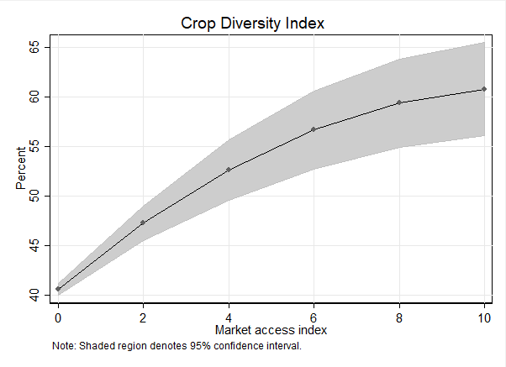
(b)
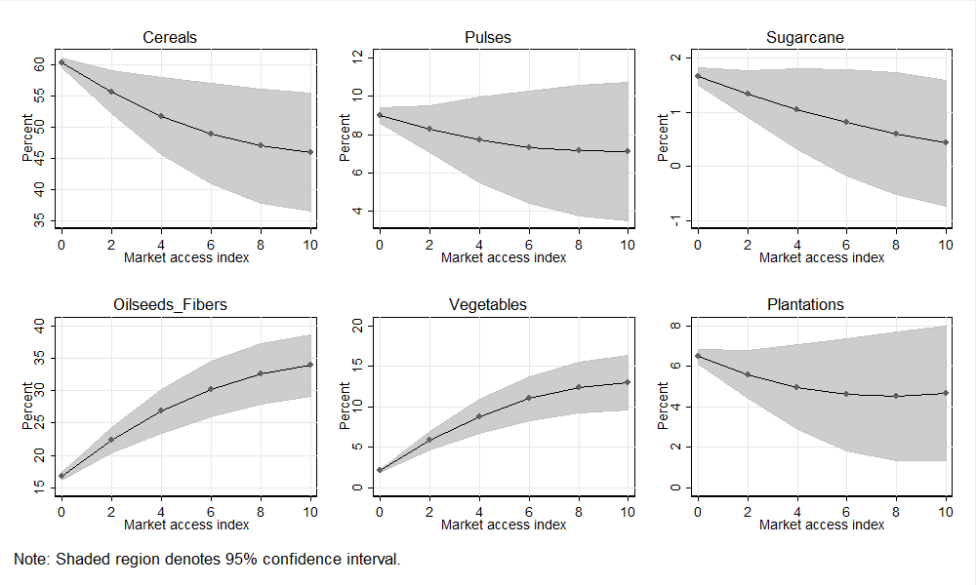

6.2 Market access and diversification by farm size

Indian agriculture is primarily carried out by smallholders; close to 70% of the farm households cultivate landholdings of less than or equal to one hectare, and often they are stuck in subsistence production. For them, diversification of agriculture in favor of comparatively remunerative crops, such as vegetables, fruits, spices, condiments and plantations, is an important means of increasing incomes (Joshi et al., 2004; Birthal et al., 2015). Small farm households have a larger endowment of labor relative to land; hence they have a comparative advantage over large farmers in cultivation of labor-intensive high-value crops. Nevertheless, market access is an important barrier to diversification on smaller farms because of the higher costs of trade associated with small marketed surplus.

Table 7 presents estimates of equation (6). In case of diversification index being dependent variable, the regression coefficients on farm classes are positive and statistically significant, indicating higher level of diversification on small, medium and large farms relative to marginal farms. Further, the extent of diversification is found to increase with farm size. For crops, relative to marginal farms, on large farms cereals, pulses, vegetables and oilseeds (including fibers) occupy proportionately less area, but not the sugar and horticultural crops. Expectedly, marginal farmers allocate a larger proportion of their land to cereals, pulses and vegetables. For them, food grains are essential for their household food security, while vegetables are labor-intensive and generate a higher and continuous stream of income that match closely their resource endowments (less land, more labor) and cash flow requirements. Sugarcane and horticultural crops although are more remunerative, their higher initial capital requirement and longer gestation period favor their cultivation on large farms that are less capital-constrained.

Table 7. Market access, crop diversity and cropping patterns by landholding sizes
 | (1) | (2) | (3) | (4) | (5) | (6) | (7)
 | Index of diversification | Cereals | Pulses | Sugar  crops | Oilseeds-  fibres | Vegetables | Horticulture
Small | 0.011*** | -1.830*** | -0.142 | 0.999*** | 0.436* | -0.191* | 0.535***
 | (0.003) | (0.258) | (0.126) | (0.172) | (0.239) | (0.101) | (0.152)
Medium | 0.018*** | -1.794*** | -0.666*** | 0.990*** | -0.261 | -0.398*** | 0.674***
 | (0.004) | (0.290) | (0.192) | (0.217) | (0.333) | (0.143) | (0.205)
Large | 0.041*** | -2.945*** | -1.445*** | 0.421 | -1.124** | -0.994*** | 0.501
 | (0.007) | (0.465) | (0.261) | (0.266) | (0.451) | (0.255) | (0.333)
Marginal*Market access | 0.009** | -0.667 | -0.074 | -0.185 | 0.258 | 0.227* | -0.275
 | (0.004) | (0.469) | (0.384) | (0.288) | (0.328) | (0.128) | (0.344)
Small*Market access | -0.002 | 0.110 | 0.188 | 0.161 | 0.030 | -0.085 | 0.066
 | (0.002) | (0.250) | (0.201) | (0.154) | (0.124) | (0.112) | (0.182)
Medium*Market access | -0.006** | 0.052 | 0.191 | 0.241 | 0.100 | -0.107 | -0.303
 | (0.003) | (0.276) | (0.182) | (0.151) | (0.362) | (0.166) | (0.196)
Large*Market access | -0.008** | 0.172 | 0.312* | 0.283* | -0.275 | -0.089 | 0.345
 | (0.003) | (0.293) | (0.175) | (0.159) | (0.369) | (0.127) | (0.640)
N | 16413 | 16166 | 16166 | 16166 | 16166 | 16166 | 16166
R² | 0.294 | 0.415 | 0.136 | 0.104 | 0.324 | 0.079 | 0.252
Notes: All regressions include state fixed effects. Base omitted category is marginal farmers. Control variables included in the regressions but their estimated coefficients are omitted in the table above. Figures in parenthesis are standard errors robust to intra-district correlation of residuals. ***, **, and * indicate statistical significance at the 1%, 5%, and 10% levels, respectively.

The effects of market access on diversification or crop choices are heterogenous across farm classes. With market access the marginal farmers tend to diversify more towards vegetables, and large farmers specialize in pulses and sugarcane. There is no significant influence of market access on crop portfolios of other farm classes. These findings imply that with market constraints relaxed, the crop choices are likely to vary across farm classes due to factors other than market access. For example, Birthal et al. (2013) observe a higher probability of cultivation of vegetables among households belonging to the socially backward classes.

  - Market distortions and diversification

Since the beginning of Green Revolution in the mid-1960s the government of India has followed a cereal-centric price policy. To provide them adequate remuneration from sales of their produce the government has been fixing floor prices, i.e., minimum support prices (MSP) for several non-perishable agricultural commodities accompanied by an assurance of their procurement if open market prices at harvest are below the government-set thresholds. Nonetheless, the policy is effectively implemented for rice and wheat that are procured in huge quantities by the government for public distribution system and buffer stocking. Generally, government procures 25-30% of the total production of rice and wheat, this proportion varies considerably across states (Figure 5). Our hypothesis is that the cereal-centric price policy acts as an impediment to agricultural diversification.

Figure 5. Procurement of cereals across states of India
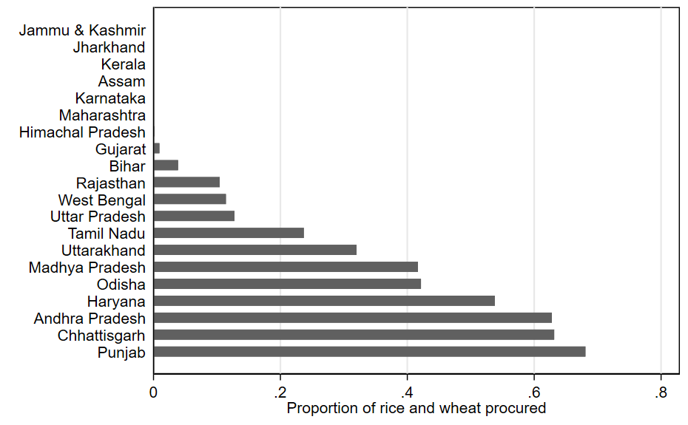

To test this hypothesis, we estimate equation 7 that includes an interaction between market access and procurement (as proportion of total production rice and wheat). As our procurement variable is at state level, the linear term drops out owing to inclusion of the state fixed effects in the equation. The estimated results are presented in Table 8. Coefficients of market access are comparable to those obtained earlier, in terms of their direction as well as level of significance. But with procurement policy these become weaker in their magnitude. For instance, in case of diversification index as dependent variable the market access carries a positive and statistically significant sign, but on its interaction with procurement the regression coefficient turns out to be opposite (Figure 6a). Area shares of most crops, except vegetables, are negatively impacted by cereal-centric price policy (Figure 6b).

To verify these findings further, we regress area shares of rice and wheat on market access and its interaction with their procurement (as proportion of their production). In case of both rice and wheat, the coefficient on market access is negative, but its interaction with procurement carries a positive sign. This means that despite market access, farmers choose to cultivate rice and wheat because of their assured procurement at government-determined prices. We conclude that policy-induced market distortions weaken positive influence of market access on crop diversification. Nonetheless, given a level playing field, farmers’ land allocation decisions will be guided by distance to markets, transportation and storage costs and market demand as implied in Von Thunen theory of agricultural specialization.

Table 8. Market access, procurement and diversification

 | (1) | (2) | (3) | (4) | (5) | (6) | (7)
 | Index of diversification | Cereals | Pulses | Sugar  crops | Oilseeds-fibres | Vegetables | Horticulture
Market access | 1.654*** | -1.351** | 0.176 | 0.112 | 0.973*** | 0.476** | -0.385*
 | (0.534) | (0.627) | (0.400) | (0.154) | (0.309) | (0.192) | (0.209)
Cereal procured*Market access | -2.480*** | 2.415** | -0.009 | -0.436 | -2.054*** | -0.479 | 0.563
 | (0.923) | (1.159) | (0.950) | (0.278) | (0.714) | (0.364) | (0.428)
N | 4138 | 4127 | 4127 | 4127 | 4127 | 4127 | 4127
R² | 0.409 | 0.470 | 0.180 | 0.137 | 0.371 | 0.119 | 0.254
Notes: All regressions include state fixed effects. Figures in parenthesis are standard errors robust to intra-district correlation of residuals. ***, **, and * indicate statistical significance at the 1%, 5%, and 10% levels, respectively.

 | (1) | (2)
 | Rice | Wheat
Market access | -1.334** | -0.070
 | (0.555) | (0.153)
Rice procurement*Market access | 2.266***
 | (0.748)
Wheat procurement*Market access |  | 0.237
 |  | (0.272)
N | 4115 | 4110
R² | 0.117 | 0.019
Notes: All regressions include state fixed effects. Figures in parenthesis are standard errors robust to intra-district correlation of residuals. ***, **, and * indicate statistical significance at the 1%, 5%, and 10% levels, respectively.

Figure 6. Effect of procurement on the relationship between market access and crop diversification
(a)
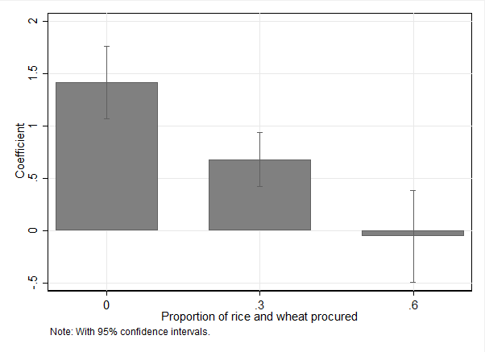
(b)

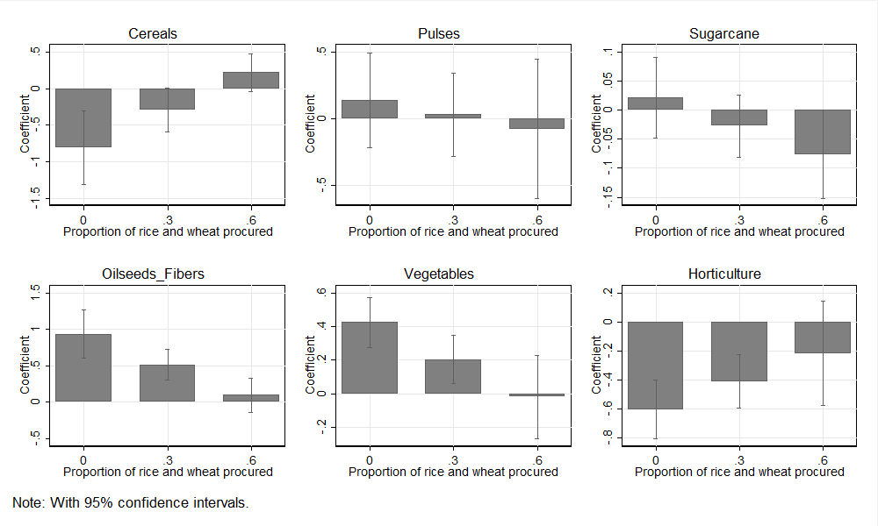

6.4 Robustness check

Literature provides several indicators of market access, e.g. the distance, transportation costs and travel time to urban centres. The selection of indicators is often ad hoc which may lead to problem of econometric specification, erroneous conclusions and imprudent implications for policy actions Chamberlin and Jayne (2013). With this in view, we test sensitivity of our results to a traditional measure of market access, i.e. travel time. The data on travel times are extracted from FAO-GAEZ database, and are based on road density. Figure 6 plots our measure of market access against travel time. We find a strong negative relationship between the two, which implies that greater market access is strongly associated with lower travel time. This makes it evident that our measure of market access is consistent with the commonly used measures of market access. However, the advantage of our measure of market access is that it is theoretically founded based on both the supply and demand sides of markets.
Figure 6. Market access index and travel times
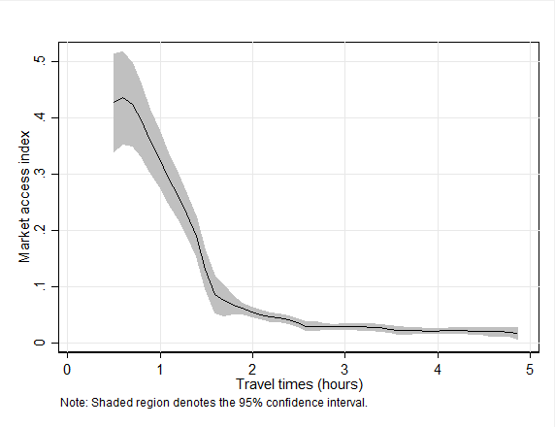
Now we estimate equation (3) replacing the index of market access by travel time. The results are presented in Table 9. The travel time does not have any significant influence on diversification index. Its effects on area shares of crops or crop groups are similar to those obtained with our measure of market access. The greater travel time discourages cultivation of vegetable and sugar crops. These are bulky commodities and entail substantial transport costs.
Table 9. Travel time and crop diversification
- Linear
 | (1) | (2) | (3) | (4) | (5) | (6) | (7)
 | Index of  diversification | Cereals | Pulses | Sugar  crops | Oilseeds-  fibres | Vegetables | Horticulture
Travel time (hours) | -0.565 | 2.416 | 1.384** | -1.176*** | -1.667 | -1.026** | 0.069
 | (1.248) | (1.502) | (0.633) | (0.393) | (1.234) | (0.429) | (0.772)
N | 4138 | 4127 | 4127 | 4127 | 4127 | 4127 | 4127
R² | 0.406 | 0.460 | 0.160 | 0.140 | 0.372 | 0.120 | 0.249
Notes: All regressions include state fixed effects. Figures in parenthesis are standard errors robust to intra-district correlation of residuals. ***, **, and * indicate statistical significance at the 1%, 5%, and 10% levels, respectively.

- Non linear
 | (1) | (2) | (3) | (4) | (5) | (6) | (7)
 | Index of  diversification | Cereals | Pulses | Sugar  crops | Oilseeds-  fibres | Vegetables | Horticulture
Travel time (hours) | 1.520 | 0.725 | 0.604 | -1.768* | -0.637 | -2.574** | 3.650**
 | (2.262) | (2.725) | (1.586) | (0.921) | (2.217) | (1.090) | (1.491)
Travel time (squared) | -0.498 | 0.404 | 0.186 | 0.141 | -0.246 | 0.370* | -0.855**
 | (0.574) | (0.598) | (0.358) | (0.146) | (0.407) | (0.223) | (0.380)
N | 4138 | 4127 | 4127 | 4127 | 4127 | 4127 | 4127
R² | 0.406 | 0.460 | 0.160 | 0.140 | 0.372 | 0.121 | 0.251
Notes: All regressions include state fixed effects. Figures in parenthesis are robust standard errors. ***, **, and * indicate statistical significance at the 1%, 5%, and 10% levels, respectively.

- Discussion

Diversification is a potential and effective strategy of enhancing agricultural growth and reducing rural poverty in developing countries. For India Minot, Joshi and Birthal (2006) and Birthal et al. (2013) identify diversification as the second largest and sustainable source of agricultural growth after technological change. Birthal, Roy and Negi (2015) for India, and Michler and Josephson (2017) for Ethiopia find diversification contributing to poverty reduction, and the impact being larger in case of smallholder farmers. Evidence also exists on its contribution to resilience of agriculture to climatic shocks (Birthal and Hazrana 2019). These studies define diversification differently in terms of in terms of its income generating potential (Joshi, Birthal and Minot 2006; Birthal et al. 2013; Birthal, Roy and Negi 2015) and risk reduction potential (Michler and Josephson 2017; Birthal and Hazrana 2019). But a common conclusion is that either way diversification contributes to sustainability of agriculture and poverty reduction.

Market access is essential to harness the pro-poor growth potential of diversification. Farmers often face difficulties in accessing remunerative markets due to their remote location, high transportation costs, asymmetry in information and lack of business skills essential to benefit from market. Several studies assess the effect of market access on indicators of agricultural development, such as technology adoption, farm performance, diversification and poverty. Emaran and Hou (2013) show that in China the improved access to markets, domestic as well as international, could reduce poverty by 4-6%, the impact being bigger in case of domestic market access. Similar evidence is reported from by Diao et al. (2019) who find that households’ proximity to larger cities i.e. greater market access is associated with lower probability of being poor. Even in developed countries like the United States, higher market access has been found to be associated with less incidence of rural poverty (Partridge and Rickman, 2008). Some studies (e.g., Minten 1999; Rao et al. 2006; Muto and Yamano 2009; Shamdasani 2016) conclude that by reducing transportation costs and travel time, roads improve farmers’ participation in markets and farm performance. In this paper the market access measure combines both the aspects of distance to the market as well as size of relevant market albeit with refined market size measure incorporating granular measures of gross domestic product and/or economic activity.

A few studies have also examined farmers’ choice of crops in response to changes in market access. Bittinger (2010) show that Ethiopian farmers do respond to market access by altering their crop portfolios; they diversify away from cereals, pulses, vegetables and fruits to high value cash crops such as oilseeds, spices and teff. From a study in Honduras, Buckmaster et al. (2014) show that there is a specific distance from market beyond which production of fruits and vegetables production does not occur as the income gains from their production are outweighed by the increased transportation costs.

Some studies have specifically investigated the relationship between crop diversification and market access in the Indian context. Joshi et al. (2004) find a positive association between crop diversification and market access measured by road density and urbanization. Rao et al. (2006) also report that the districts having a better road network and ones that are closer to urban centers are comparatively diversified towards vegetables and dairying, but not towards fruits and plantation crops. Likewise, Shamdasani (2016) also shows that rural roads create incentives for farmers to allocate more land to high value crops and to use improved technologies and farm inputs.

Note that most studies use distance from the urban center, road connectivity or urbanization as a measure of market access. Emran and Shilpi (2012) develop a comprehensive measure of market access that integrate distance to urban center and market size into a single measure and examine its association with crop diversification, area share of cash and non-cash crops in Nepal. This study provides two important conclusions (i) diversification is driven by cash crops and (ii) the relationship between market access and diversification is non-linear where farmers initially responds to market access by altering their crop portfolio in favor of high value crops, but after a threshold revert to specializing in staple crops, i.e. there is an inverted U shaped association between market access and diversification.

Our results are quite consistent with those reported by Emran and Shilpi (2012) for Nepal. As for Nepal, the diversification-market access curve after initial spurt seems to be concave. i.e., an increase in diversification with market access, but after a threshold the relationship becomes weak possibly due to barriers other than markets. Amongst crops, we find this relationship valid for vegetables, oilseeds and fibres and not for other cereals, pulses, sugarcane and horticulture. The scope of our paper is broader in scope. It unpacks the effect of market access on individual crops or crop groups and by farm size. Moreover, it shows how government interventions in food grain market can retard the pace of market-led diversification.

After a subjective threshold, in expanding the scale of production, small farmers may face capital constraint, while labor and supervision cost could be binding factors for large farmers. Moreover, our findings by farm size show that compared to others, smallholders allocate a larger share of their area to vegetables that are labor intensive and generate higher returns on a regular basis as these characteristics match with their resource endowments and cash flow requirements.

Finally, our findings show that policy-induced distortions in food grain markets cause distortions in cropping pattern and deprive farmers from the benefits of diversification into relatively more remunerative cash crops. Such policies act as disincentive to private investment in markets and associated infrastructures essential for diversification. Leaving aside the disincentive effect, such a price policy benefits more to farmers in irrigated regions specializing in rice and wheat. There is also an argument that since the benefits of administered minimum support prices are directly proportional to the marketed surplus, farmers with larger surpluses benefit more from the pricing system (Joshi, Birthal and Minot 2006).

Diversification may be pitched against several poverty alleviation and social protection programs that require large public resources and often suffer from targeting errors. Our results show that diversification is far more inclusive, and is more sustainable means of poverty reduction in agrarian economies particularly those dominated by smallholders.

- Conclusions and implications

In this paper we study the structural transformation in agriculture in India in terms of product diversification and commercialization. This transformation process is of great importance to India as still about half of the population depends on agriculture for employment. As agriculture transforms structurally, issues remain about extent of commercialization and specialization in a smallholder dominated system that characterizes Indian agriculture. The main objective of this paper was to analyze structural transformation within agriculture and assess the catalytical role played by markets (i.e., the size of the relevant market). We used novel data on local GDP and gravity model type measures for relevant market for a production location. Using granular gridded data to account for agroecological suitability we analyze both dimensions of structural change i.e. the pattern of product diversification and the extent of market access that agricultural economist accept as commercialization of agriculture. Apart from crop diversification index we also look at allocations to individual crops to gauge the leaders driving diversification and specialization.

Traditionally the nearest urban center has been taken as a measure of market for agricultural producers located in rural areas. Using gridded data and the measure of local GDP, we use a much broader measure of size of relevant market. In empirical estimation, we also address the possible endogeneity of the market access using heteroscedasticity in error terms for identification following Lewbel (2012). We also test for non-linearity in the relationship between market access and cropping choices and find evidence in support of such a relationship.

The results show a statistically significant effect of the extent of the market on diversification away from principal cereal crops i.e. rice and wheat. The evidence clearly indicates this movement to be significantly determined by relevant market size. The results imply that for the farmers to move out of subsistence production dominated by production of grains, access to richer urban centers is required, and a level playing field will motivate farmers to diversify more.

References

Amare, M., N.D. Jensen, B. Shiferaw, and J.D. Cisse. 2018. Rainfall Shocks and Agricultural Productivity: Implication for Rural Household Consumption. Agricultural Systems 166:79-80.

Barghouti, S., S. Kane, S. Kristina, and .M Ali. 2004. Agricultural Diversification for the Poor: Guidelines for Practitioners. Agriculture and Rural Development Discussion Paper No. 1. Washington, DC: World Bank.

Barrett, C. (2007). Smallholder market participation: Concepts and evidence from Eastern and Southern Africa. Food Policy 33: 299-317.

Bergsten, A., and S. Tengstam. 2011. Smallholder Diversification and Income Growth in Zambia. Journal of African Economies 20(5): 781-822.

Birthal, P.S., and J. Hazrana. 2019. Crop Diversification and Resilience of Agriculture to Climatic Shocks: Evidence from India. Agricultural Systems 173: 345-354.

Birthal, P.S., D.S. Negi, D. Roy. 2017. Enhancing Farmers’ Income: Who to Target and How? Policy Paper 30. New Delhi: National Institute of Agricultural Economics and Policy Research.

Birthal, P.S., P.K. Joshi, D.S. Negi, and S. Agarwal. 2014. Changing Sources of Growth in Indian Agriculture: Implications for Regional Priorities for Accelerating Agricultural Growth. IFPRI Discussion Paper 01325. Washington DC: International Food Policy Research Institute.

Birthal, P. S., S. Kumar, D.S. Negi and D. Roy. 2015. The Impacts of Information on Returns from Farming: Evidence arom a Nationally Representative Farm Survey in India. Agricultural Economics 46(4): 549-561.

Birthal, P.S., D. Roy, P.K. Joshi, and A. Thorat, A. 2013. Diversification in Indian agriculture toward High‐value Crops: The Role of Small Farmers. Canadian Journal of Agricultural Economics 61(1):61-91.
Birthal, P. S., D. Roy, and D.S. Negi. 2015. Assessing the Impact of Crop Diversification on Farm Poverty in India. World Development 72: 70-92.

Bittinger, A.K. 2010. Crop Diversification and Technology Adoption: The Role of Market Isolation in Ethiopia. Master’s thesis, Montana State University.

Buckmaster, A., J. Alwang, E. Peterson, and M. Rivera. 2014. Going the Distance: How Does Market Access Affect Demand for IPM Packages? Journal of Integrated Pest Management 5(1): B1–B7

Bustos, P., B. Caprettini, and J. Ponticelli. 2016. Agricultural Productivity and Structural Transformation: Evidence from Brazil. American Economic Review 106(6): 1320-1365.

Chamberlin, J., and T.S. Jayne. 2013. Unpacking the Meaning of ‘Market Access’: Evidence from Rural Kenya. World Development 41(1): 245-264.

Deichmann, U., F. Shilpi, and R. Vakis. 2009. Urban Proximity, Agricultural Potential and Rural Non-Farm Employment: Evidence from Bangladesh. World Development 37(3): 645-660.

de Janvry, A., M. Fafchamps, and E. Sadoulet. 1991. Peasant Household Behaviour with Missing Markets: Some Paradoxes Explained. The Economic Journal 101(409):1400-1417.

Diao, X., E. Magalhaes, and J. Silver. 2019. Cities and Rural Transformation: A Spatial Analysis of Rural Livelihoods in Ghana. World Development 121: 141-157.

Dorward, A., S. Fan, J. Kydd, H. Lofgren, J. Morrison, C. Poulton, N. Rao, L. Smith, H. Tchale, S. Thorat, I. Urey, and P. Wobst. 2004. Institutions and Policies for Pro-poor Agricultural Growth. Development Policy Review 22(6): 611-622.

Emran, M. S., and Z. Hou. 2013. Access to Markets and Rural Poverty: Evidence from Household Consumption in China. Review of Economics and Statistics 95(2): 682-697.

Emran, M. S., and F. Shilpi. 2012. The Extent of The Market and Stages of Agricultural Specialization. Canadian Journal of Economics 45(2): 1125-1153.

Fafchamps, M., and F. Shilpi. 2003. The Spatial Division of Labor in Nepal. Journal of Development Studies 39(6): 23-66.

Foster, A. D., and M.R. Rosenzweig. 2004. Agricultural Productivity Growth, Rural Economic Diversity, and Economic Reforms: India, 1970-2000. Economic Development and Cultural Change 52 (3): 509 – 542.

Gao, W., and R. Smyth. 2015. Education Expansion and Returns to Schooling in Urban China, 2001–2010: Evidence from Three Waves of the China Urban Labor Survey. Journal of the Asia Pacific Economy 20(2):178-201.

Ghosh, T., R.L. Powell, C.D. Elvidge, K.E. Baugh, P.C. Sutton, and S. Anderson. 2010. Shedding Light on the Global Distribution of Economic Activity. The Open Geography Journal 3:148-161.

Gibson, J., G. Datt, R. Murgai, and M. Ravallion. 2017. For India’s Rural Poor, Growing Towns Matter More Than Growing Cities. World Development 98: 413-429.

Gollin, D., S. Parente, and R. Rogerson. 2002.The Role of Agriculture in Development. American Economic Review 92(2): 160-164.

Gulati, A., N. Minot, C. Delgado, and S. Bora. 2007. Growth in High-Value Agriculture in Asia and the Emergence of Vertical Links with Farmers. In: Global Supply Chains, Standards and the Poor: How the Globalization of Food Systems and Standards Affects Rural Development and Poverty (Ed. Johan Swinnen). Wallingford: CABI.

Hellin, J., M. Lundy, and M. Meijer,. 2009.Farmer Organization, Collective Action and Market Access in Meso-America. Food Policy 34(1):16-22.

Jayne, T.S., and J. Govereh. 2003. Cash Cropping and Food Crop Productivity: Synergies or Trade-offs? Agricultural Economics 28: 39-50.

Johnston, B.F. 1970. Agriculture and Structural Transformation in Developing Countries: A Survey of Research. Journal of Economic Literature 8(2): 360-404.

Joshi, P. K., A. Gulati, P.S. Birthal, and L. Tewari. 2004. Agriculture Diversification in South Asia: Patterns, Determinants and Policy Implications. Economic and Political Weekly 39(24): 2457-2467.

Kydd J., and A. Dorward. 2004. Implications of Market and Coordination Failures for Rural Development in Least Developed Countries. Journal of International Development 16(7): 951-970.

Lewbel, A. 2012. Using Heteroscedasticity to Identify and Estimate Mis-Measured and Endogenous Regressor Models. Journal of Business & Economic Statistics 30(1): 67-80.

Lin, F., E.O. Weldemicael, and X. Wang .2017. Export Sophistication Increases Income in Sub-Saharan Africa: Evidence from 1981–2000. Empirical Economics 52(4): 1627-1649.

Meenakshi, J. V., Banerji, A. (2005). The Unsupportable Support Price: An Analysis of Collusion and Government Intervention in Paddy Auction Markets in North India. Journal of Development Economics 76(2): 377-403.

Michler, J. D., and A.L. Josephson. (2017). To Specialize or Diversify: Agricultural Diversity and Poverty Dynamics in Ethiopia. World Development 89: 214-226.

Minten, B., and C. Barrett. 2008. Agricultural Technology, Productivity, and Poverty in Madagascar. World Development 36(5): 797-822.

Muto, M., and T. Yamano. 2009. The Impact of Mobile Phone Coverage Expansion on Market Participation: Panel Data Evidence from Uganda. World development 37(12): 1887-1896.

Mishra, V., and R. Smyth. 2015. Estimating Returns to Schooling in Urban China Using Conventional and Heteroskedasticity-based Instruments. Economic Modelling 47: 166-173.

Negi, D. S., P.S. Birthal, D. Roy and Md. Tajuddin Khan. 2018. Farmers’ Choice of Market Channels and Producer Prices in India: Role of Transportation and Communication Networks. Food Policy 81: 106-121.

Partridge, M. D., and D.S. Rickman. 2008. Distance from Urban Agglomeration Economies and Rural Poverty. Journal of Regional Science 48 (2): 285-310.

Poulton, C., J. Kydd, and A. Dorward. 2006. Overcoming Market Constraints to Pro-Poor Agricultural Growth in Sub Saharan Africa. Development Policy Review 24(3): 243-277.

Rao P. P., P.S/ Birthal, and P.K. Joshi. 2006. Diversification towards High-value Agriculture: Role of Urbanization and Infrastructure. Economic and Political Weekly 41 (26): 2747-2753.

Rashid, S., R. Cummings, and A. Gulati. 2005. Grain Marketing Parastatals in Asia: Why Do They Have to Change Now? MTID Discussion Paper No. 80. Washington DC: International Food Policy Research Institute

Shamdasani, Y. 2016. Rural Road Infrastructure and Agricultural Production: Evidence from India.
Department of Economics, Columbia University.

Sharma, A. 2016. Urban Proximity and Spatial Pattern of Land Use and Development in Rural India. Journal of Development Studies 52(11): 1593-1611.

Shiferaw, B., J. Hellin, and G. Muricho. 2011. Improving Market Access and Agricultural Productivity Growth in Africa: What Role for Producer Organizations and Collective Action Institutions? Food Security 3(4): 375-389.

Von Thunen, J. H. (1826). The Isolated State, translated by CM Wartenberg (1966).

White, H. 1980. A Heteroskedasticity-consistent Covariance Matrix Estimator and a Direct Test for Heteroskedasticity. Econometrica 48(4): 817-838.

Wood, S. 2007. Spatial Dimensions of the Regional Evaluation of Agricultural Livelihood Strategies: Insights from Uganda. Doctoral Dissertation, London: Department of Economics, University of London.

