The Weight of Empowerment: Intrahousehold Status and Women’s Obesity in India

Kuhu Joshiª and Avinash Kishoreª
ªInternational Food Policy Research Institute

Abstract
Better status in the family is associated with higher body mass index (BMI) for women in developing countries. This is a desirable outcome of empowerment for a large number of women who are underweight. However, the recent National Family Health Survey (NFHS-4) data shows that high BMI is a growing problem for women in all parts of India. Does the correlation between household status and BMI change sign for women with high BMIs (>25 kg/m²)? We use quantile regression with NFHS-4 data to measure the correlation between plausibly exogenous measures of intra-household status of married women and their BMI over the entire distribution of the BMI values. In a culture that prefers sons, a woman has higher intrahousehold status if her first-born child is male. We find that having a first-born male child increases a woman’s BMI across all BMI percentiles: by 0.01 standard deviations at the bottom two percentiles (where BMI ≤ 18 kg/m²), by 0.05 standard deviations between the 30th and 70th percentiles (where BMI is 19 to 23 kg/m²), and by 0.02 standard deviations at the top two percentiles (where BMI ≥ 24 kg/m²). Our results are robust to the inclusion of other measures of intrahousehold status like education and occupation. We trace two mechanisms through which improved status can lead to higher BMI in an obesogenic environment. One, improved status is associated with higher leisure consumption: women whose first-born child is male are 0.4% more likely to watch television daily/weekly. Two, improved status is associated with a 2% higher likelihood of eating out, especially in urban areas.

- Introduction
A growing literature in developing countries identifies a woman’s intrahousehold status as an important determinant of her health and wellbeing. An improvement in intrahousehold status can improve dietary diversity and increase body mass index (BMI). It can lower the probability of being underweight and anaemic, and lead to lower levels of mortality and morbidity (Calvi, 2017; Malapit, Kadiyala, Quisumbing, Cunningham, & Tyagi, 2013; Ross, Zereyesus, Shanoyan, & Amanor-Boadu, 2015). A woman’s intrahousehold status is also an important determinant of her children’s health and wellbeing (L. C. Smith, Ramakrishnan, Ndiaye, Haddad, & Martorell, 2002). For instance, Coffey, Khera, and Spears (2015) show that Indian women with lower intrahousehold status have shorter children and attribute this partly to lower maternal BMI.
Historically, a large proportion of Indian women were underweight, and consequently, higher BMI was a desired outcome of improved status. This is changing rapidly. Between 2005-06 and 2015-16, the prevalence of underweight (BMI ≤ 18 kg/m²) has gone down from 35.5% to 22.9%, while the prevalence of overweight and obesity (BMI ≥ 25 kg/m²) has risen from 12.60% to 20.70% among women in the 15-49 years age group in India (International Institute for Population Studies, 2017). The rise in overweight and obesity among women is no longer restricted to urban areas. Rural overweight/obesity has doubled from 7.5% in 2005-06 to 15% in 2015-16. Urban overweight/obesity has also increased from 23.6% in 2005-06 to an alarming 31% in 2015-16.
Data from the National Family Health Survey conducted in 2015-16 (NFHS-4) shows that between 20 to 40 percent of women are overweight/obese in nearly every district in urban India (Figure 1). Rural overweight/obesity is also consistently high across districts and is lower than 10 percent only in the poorest states in Eastern India. (Figure 2).
There is also a significant gender gap in the incidence of overweight/obesity in India. More women are overweight/obese compared to men in both urban and rural areas (Figure A1 and A2 in the Appendix). In an earlier paper on obesity in India, we showed that this gender gap persists even when we compare women and men within households (Joshi, Roy, Iannotti, Nagar, & Kishore, 2019). The probability of being overweight/obese also increases with age and rises more rapidly with age for women in urban areas compared to rural areas (Figure 3).
Clearly, a higher BMI is no longer a desirable outcome for a large and growing proportion of women in India. In the background of rising overweight and obesity, we re-examine the impact of intrahousehold status on women’s BMI, using the latest nationally representative datasets on health and nutrition in India – the National Family Health Survey conducted in 2015-16 and the National Sample Survey conducted in 2011-12.
A higher BMI may be desirable for underweight women whose BMI is below 18 kg/m². But for women whose BMI is on the margins (i.e., above 22 kg/m²), increasing BMI will lead to a greater risk of overweight/obesity and associated non-communicable diseases like diabetes and hypertension (Martorell, Khan, Hughes, & Grummer-Strawn, 2000; Solomon & Manson, 1997). The implications of the impact of status on BMI will therefore vary according to a woman’s current BMI level. We use quantile regression to study the relationship between intrahousehold status and BMI at different quantiles of BMI. Unlike ordinary least squares, which gives the average effect, quantile regression allows us to assess the impact of woman’s status on BMI over the entire distribution of BMI values.
Measuring intrahousehold status is not quantitatively straightforward. Previous studies have used survey-reported indicators of women’s ‘say’ in household decisions, or their perceptions towards domestic violence, but such measures suffer from considerable bias and misreporting (Coffey et al., 2015). For the ‘say’ indicators, there is no consensus on how a jointly made household decision (i.e., a decision made jointly by husband and wife) should be treated in comparison with the case where the woman alone takes a decision (Seymour & Peterman, 2018). A woman’s intrahousehold status is also related to factors like her education, caste, and household wealth, but unique to India (and a few other Asian countries), is its association with the first-born child’s sex. Son-preference has been a persistent cultural phenomenon, and research shows that having a first-born girl rather than boy, significantly reduces a woman’s intrahousehold status.
We measure intrahousehold status by the first-born child’s sex as it is exogenously determined and has been established as a robust indicator of status in previous papers (Kishore & Spears, 2014; Milazzo, 2018). We additionally use a second measure, proposed by Coffey et. al. (2015) wherein the higher ranked daughter-in-law (badi-bahu) in a patrilocal joint family has higher intrahousehold status than the lower ranked daughter-in-law (chhoti-bahu). Higher status, as measured by the first child being male, increases a woman’s BMI across the entire distribution of BMI values. Higher ranked daughters-in-law (badi-bahus) are more likely to be overweight/obese in joint families than lower ranked daughters-in-law (chhoti-bahus). Using other objective measures that reveal status, also points to the same conclusion: women who are more educated, women who work in paid jobs in offices, and women who married at an older age, are all more likely to be overweight/obese.
We further try to trace mechanisms linking status to BMI, focusing on consumption of leisure and dietary habits. Historically, women’s time use has been determined by socio-cultural norms that reward ‘purity’ (Eswaran, Ramaswami, & Wadhwa, 2013). Women have had restricted mobility and low participation in paid work outside the house. Only the poorest are engaged in labour intensive work to meet their household’s basic income requirements (Rao, Verschoor, Deshpande, & Dubey, 2010). Moreover, women are often responsible for cooking meals for the entire household, and are expected to eat last, after men and children, often having to do with poorer diets.
The socio-economic scenario in India is now undergoing rapid change, with urbanization, rising wealth and education, and more sedentary leisure and work (Dang & Meenakshi, 2017; Misra et al., 2011; Popkin, Horton, Kim, Mahal, & Shuigao, 2009). Many tasks predominantly performed by women, such as fetching water, washing clothes, and cooking for the family, have also become less labour intensive. There is simultaneously an increase in the availability of more obesogenic foods rich in saturated fats and sugar, and the growth of restaurants and fast food joints (Gaiha, Jha, & Kulkarni, 2013; Patel et al., 2017). Packaged snacks (like chips and biscuits) are increasingly available even in more remote rural locations.
We find that women with higher intrahousehold status tend to have higher leisure consumption and a higher likelihood of eating paid meals outside of home/in restaurants compared to women with lower intrahousehold status. These are two of the possible mechanisms via which status increases BMI and the propensity for overweight/obesity among women in India.
Our paper contributes to two sets of literature – the literature on the impact of women’s intrahousehold status on their health and wellbeing, and the literature on overweight and obesity. Notably, we depart from the commonly believed notion that the positive relationship between status and BMI is necessarily a desirable one. We also show that improved intrahousehold status is associated with sedentary behaviours and unhealthy dietary habits among women.
In an obesogenic environment, characterized by a high consumption of leisure, sedentary jobs, and processed and packaged foods, it seems that more empowered women are not necessarily making choices that are good for their health. Our paper shows that higher BMI seems to have become a penalty or a collateral loss for higher intrahousehold status. A higher than normal BMI is not desirable for women as it puts them at a greater risk for obesity-related non-communicable diseases like diabetes and hypertension (Martorell et al., 2000; Solomon & Manson, 1997).
We believe that it is necessary to curb the growth of the obesogenic environment in India, without which, improving status can worsen the health and wellbeing of a significant proportion of women. At present, health policy in India is focussed on the problem of undernutrition, but the rising burden of overweight and obesity among women also requires our attention.
The rest of this paper proceeds as follows. Section 2 describes the data and empirical methodology. Section 3 presents our main results on the impact of intrahousehold status on BMI. Section 4 presents evidence on possible mechanisms via which intrahousehold status can increase BMI. Section 5 concludes the paper.
Figure 1: Percentage of women overweight/obese (BMI ≥ 25 kg/m²) in districts of urban India
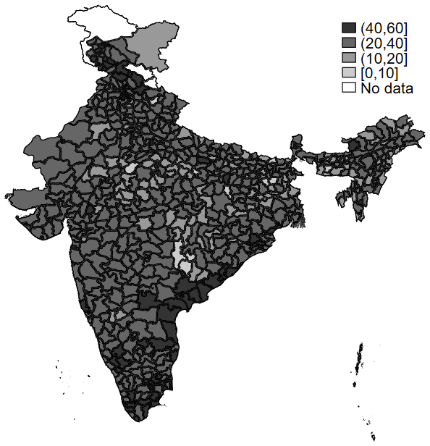
Figure 2: Percentage of women overweight/obese (BMI ≥ 25 kg/m²) in districts of rural India
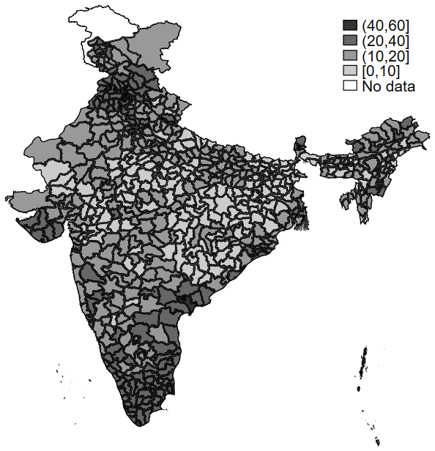
Figure 3: Overweight and obesity among women in urban and rural India, conditional on age
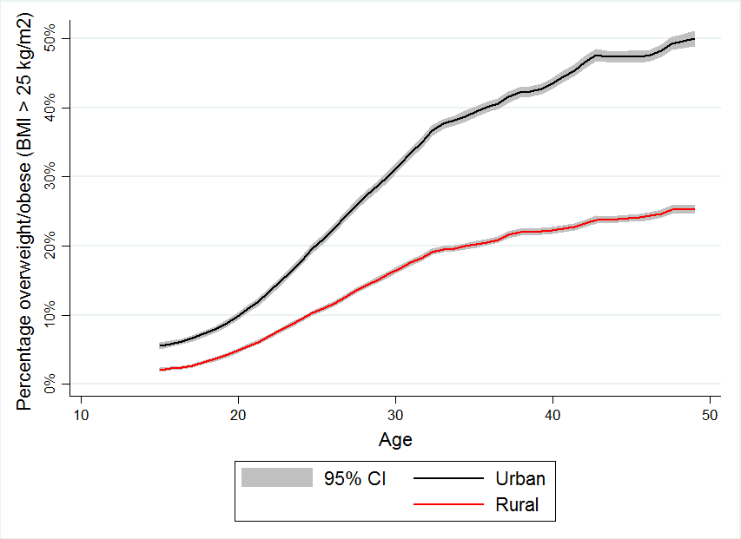

- Data and empirical methodology
2.1. The effect of intrahousehold status on BMI
We hypothesize that intrahousehold status plays a role in explaining differences in BMI among women in India. For empirical analysis, we use the nationally representative National Family Health Survey (NFHS-4) data from 2015-16 comprising of 699,686 adult women aged 15-49 years. NFHS is a part of the Demographic and Health Survey (DHS) program and has been especially useful for researchers’ and policymakers’ understanding of outcomes related to nutrition and health. The dataset provides detailed information on health, nutrition, family planning, morbidity, and mortality and is readily comparable to DHS data from other developing and middle-income countries around the world (Coffey & Spears, 2018).
Our dependent variable is the body mass index (BMI) of sample women, measured in kg/m². According to World Health Organization (WHO) standard, BMI below 18 is considered thin, BMI between 18 and 25 is considered normal, BMI between 25 and 30 is considered overweight, and BMI over 30 is considered obese (World Health Organization, 2000). Indians, and more generally Asians, are more vulnerable to obesity-related NCDs, facing a higher risk at BMI levels below the standard cut off of 25 kg/m² (Popkin, Adair, & Ng, 2012). BMI above 23 kg/m² is now recognized as overweight and BMI above 25 kg/m² as obese among the Indian population (Aziz, Kallur, & Nirmalan, 2014; Nguyen, Adair, Suchindran, He, & Popkin, 2009; WHO Expert Consultation, 2004).
We measure intrahousehold status by an exogenously determined indicator: first-born child’s sex. Having a male first-born child is associated with higher status in a culture that prefers sons (S. Bhalotra, Brulé, & Roy, 2018; Clark, 2000). Previous studies have also shown that women whose first child is male have higher intrahousehold status and greater BMI than women whose first child is female (Kishore & Spears, 2014; Milazzo, 2018).
We re-examine the relationship between status and BMI, departing from the commonly held belief that status-led increase in BMI is desirable for women’s health. It may be desirable for women at below-normal BMI levels, but is detrimental to women with high BMI who are either already overweight/obese or at the margins.
Like Kishore and Spears (2014) and Milazzo (2018), we consider the first child’s sex, rather than the sex composition of all children ever born, because son-preference can lead to differential fertility stopping behaviour depending on the sex composition of children already born. For example, women who have a daughter first are more likely to have repeated and closely spaced future pregnancies in attempts to have a son (Milazzo, 2018). This differential stopping behaviour can differentially affect women’s health and BMI, and can also be correlated with other unobserved variables, leading to endogeneity in estimation.
A major threat to causal identification using first child’s sex is that families can practice sex-selective abortion. However, there is evidence that sex-selective abortion is more common at higher birth orders rather than at the first birth order in India (S. R. Bhalotra & Cochrane, 2010; Jha et al., 2011; Rosenblum, 2013). To still ensure that child sex is exogenous in our sample, we replicate our results for the sub-sample of women who report never having terminated a pregnancy. We expect to see qualitatively similar results for this sub-sample. We also remove the sub-sample of women who are currently pregnant and women who gave birth in the two years preceding survey.
We use quantile regressions to causally estimate the relationship between first child’s sex and BMI. Unlike ordinary least squares, quantile regression does not assume an underlying parametric distribution. It models the entire conditional distribution of the data, giving a more complete picture of the relationship between intrahousehold status and BMI.
We consider percentiles of BMI to show how the first child’s sex affects BMI at each percentile. This methodology also allows us to discern whether status affects BMI of the thinnest women in the same way as it does of the women with normal weights or overweight/obese women. We are particularly interested to know whether there is a switch in the sign of the relationship between status and BMI at higher than normal levels of BMI.
Percentiles of BMI are denoted by τ and the corresponding BMI conditional on a variable X is given by Q_{τ} (BMI|X). A woman is at the τ^{th} percentile of BMI if her BMI is higher than the percentage τ and lower than the percentage (1 - τ) of sample women. The regression model is specified as follows:
$$Q_{τ}\left({BMI}_{i} | {First_child_is_male}_{i}\right)= {{First_child_is_male}_{i} β}_{τ}+ ε_{τ}$$
We are interested in the coefficients $β_{τ}$of the variable ${First_child_is_male}_{i}$ from each percentile regression, where ${First_child_is_male}_{i}$ is equal to 1 if the first-born child of the i^{th} woman is male. It is equal to 0 if the first-born child is female.
We perform regressions separately for the full sample, sub-sample who have never terminated a pregnancy, the urban sample, and the rural sample of mothers. We control for age, square of age, religion, caste, and household wealth in our regressions. Additionally, we also control for the education and occupation of women as these two factors are likely to be associated with both their intrahousehold status and the propensity to be overweight/obese .
As a test for the robustness of our results, we use a second measure of intrahousehold status: a woman has higher status if she is the higher ranked daughter-in-law (badi-bahu) in a joint patrilocal family (Coffey et al. 2015). Like Coffey et al. 2015, we use the subset of 2,850 joint patrilocal households living in both urban and rural India. Joint patrilocal households are those in which adult sons live with their parents, their wives, and their children. We consider only those instances where there are two married sons. In such cases, women who are married to the older son (badi-bahus) have a higher intrahousehold status than women who are married to the younger son (chhoti-bahus).
Coffey et al. 2015 show that status is assigned after a woman marries into a joint household, and marriage does not sort women of different statuses into different ranks. Thus, a daughter-in-law’s rank is exogenously determined, and a lower rank implies lower intrahousehold status, while a higher rank implies higher intrahousehold status.
We use intra-household regressions to causally estimate the relationship between daughter-in-law’s rank and BMI, estimating coefficients from the following regression:
$${BMI}_{ih}= β{ chhoti_bahu}_{ih}+ α_{h}+ ε_{ih}$$
where i denotes individual women; h denotes households; $α_{h}$ is a set of household fixed effects; ${ chhoti_bahu}_{ih}$ denotes the lower-ranked daughter in law in a household.
2.2. Mechanisms linking intrahousehold status to BMI
We study whether leisure and eating habits are possible mechanisms linking intrahousehold status to women’s overweight and obesity in India.
We use the frequency of watching television as a proxy for leisure consumption (in the absence of recent time-use data in India) and a linear probability model to estimate the effect of intrahousehold status. The dependent variable is a binary indicator of whether a woman watches TV frequently, or not. It is created using information from NFHS-4 on the frequency of watching television, coded as - never watch, watch occasionally, watch weekly, and watch daily. We combine those who watch TV weekly and daily into the category of women who frequently watch TV. In each regression, we also control for other variables that might affect television watching, like education, age, caste, religion, and household wealth.
NFHS-4 records the frequency of an individual’s consumption of food groups — cereals, pulses, fruits, vegetables, eggs, fish, meat, aerated drinks, and fried foods — in the week before the survey. However, the food consumption data in NFHS-4 is imprecise and inconsistent with other national surveys (Coffey & Spears, 2018; Griffiths & Bentley, 2001; Joshi et al., 2019).
We use the household consumer expenditure survey (CES) data collected by the National Sample Survey (NSS) in 2011-12 (68th round) for the information on eating habits. The NSS-CES is a widely used data source on food consumption in India. The NSS-CES collects data on the number of paid meals taken away from home during the previous 30 days from every member of the sampled households. We create a binary eating-out indicator variable for all 225,947 women in the 15-49 years age group from the NSS-CES sample and study its relationship with intrahousehold status using linear probability models.
Since NSS-CES doesn’t have information on first child’s sex, we use daughter-in-law’s rank in joint patrilocal households to measure intrahousehold status in these regressions. We additionally control for other factors that may affect eating out, like the number of days spent away from home, total paid meals of other household members, and other free meals taken outside the home.
- Results: The effect of intrahousehold status on BMI
In the full sample of mothers, we find that improved intrahousehold status, as measured by the first-born child’s sex, leads to higher BMI. We present our main results in Table 1. Each cell denotes coefficients of the effect of the variable ‘First child is male’ on BMI across BMI percentiles. It also shows the average OLS coefficient from a corresponding linear regression (column 0). Standard errors are clustered at the primary sampling unit (village in rural areas and municipality in urban areas) and depicted in parentheses.
The OLS coefficient from the full sample of mothers is 0.08. We interpret this result as follows: women whose first-born child is male have on average 0.08 kg/m² higher BMI (or 0.017 standard deviations higher BMI) than those whose first-born child is female.
From the quantile regressions, we find that the coefficients are positive and highly statistically significant through the entire distribution of BMI values. The effect size ranges from 0.05 at the 10th percentile to 0.11 at the 70th percentile. It increases monotonically up to the 50th BMI percentile of 21 kg/m² after which it stays stable till the 90th percentile. At the 90th percentile BMI of 27.23 kg/m², the effect size falls slightly from 0.10 to 0.08, but it is still positive, which means that even for women who are overweight/obese, an increase in intrahousehold status leads to an increase in BMI.
Overall, Table 1 shows that BMI increases by 0.01 standard deviations at the bottom two percentiles (where BMI ≤ 18 kg/m²), by 0.05 standard deviations between the 30th and 70th percentiles (where BMI 19 to 23 kg/m²), and by 0.02 standard deviations at the top two percentiles (where BMI ≥ 24 kg/m²).
Next, we restrict our sample to those mothers who have reportedly never terminated a pregnancy, in order to plausibly rule out the chances of sex-selective abortion. Results reported in Table 1 show that the impact of status on this sub-sample of women is also positive and increasing with increasing BMI percentiles. It is unlikely, therefore, that our results suffer from endogeneity due to sex-selective abortion.
When we look at rural and urban subsamples of mothers separately, we find that this pattern holds in both areas (Table 1). In urban areas, the magnitude of the effect is much larger at lower BMI percentiles--it is double the magnitude of the coefficients in rural areas. In urban areas, the coefficient is statistically not significant at the 90th percentile of BMI, i.e., for women who are close to the threshold of obesity with BMIs greater than 29.19 kg/m².
We use a second measure of intrahousehold status — daughter-in-law’s rank — to verify the robustness of our main result. Running intrahousehold regressions on the sub-sample of patrilocal joint families that have two daughters-in-law, we find that lower-ranked daughters-in-law (chhoti-bahus) have 0.569 kg/m² lower BMI than higher-ranked daughters-in-law (badi-bahus) (Table 2). This relationship is prominent in the rural sample while due to a smaller sample size, it is imprecisely estimated in the urban sample. Using a previous round of NFHS, Coffey et. al. (2015) also find an effect of comparable magnitude, ranging between 0.345 and 0.440 kg/m².
To further verify the robustness of our result, we consider other variables that might be important in explaining some of the variation in women’s BMI. More educated women and women who work in salaried jobs in offices are more likely to have higher intrahousehold status than their counterparts (Klasen & Pieters, 2012; Martorell et al., 2000). They are also more likely to be overweight/obese.
We plot linear polynomial regression graphs to depict the relationship between the probability of being overweight/obese (conditional on age) for different levels of education and for different types of occupations. In these graphs, we consider BMI ≥ 25 kg/m² as indicating overweight/obesity (World Health Organization, 2000). We find that women who have received higher education (greater than 12 years of education) are more likely to be overweight/obese at every age compared to those who have secondary or primary school education (Figure 4). Moreover, for women who are more educated, the chances of overweight/obesity increase at a faster rate with age.
We then plot the same relationship for the following three occupation types: office work, no paid work, and agriculture/manual labour work. We find that women who are working in offices are more likely to be overweight/obese compared to women who are not engaged in paid work, followed by women who are engaged in agriculture and manual labour work (Figure 5). Again, the vertical gap between the curves increases with age. The likelihood of overweight/obesity rises faster with age for women who are working in offices.

Table 1: Relationship between first child’s sex and mother’s BMI
 |  | (0) |  | (1) |  | (2) |  | (3) |  | (4) |  | (5) |  | (6) |  | (7) |  | (8) |  | (9)
Coefficients of ‘First child is male’ |  | OLS  coefficient |  | 10th percentile |  | 20th percentile |  | 30th percentile |  | 40th percentile |  | 50th percentile |  | 60th percentile |  | 70th percentile |  | 80th percentile |  | 90th percentile |  | Sample size
Full Sample |  | 0.079*** |  | 0.050*** |  | 0.070*** |  | 0.080*** |  | 0.090*** |  | 0.110*** |  | 0.090*** |  | 0.110*** |  | 0.100*** |  | 0.080** |  | 440,512
 |  | (0.015) |  | (0.014) |  | (0.014) |  | (0.015) |  | (0.015) |  | (0.015) |  | (0.017) |  | (0.020) |  | (0.024) |  | (0.033)
Corresponding BMI |  |  |  | 17.12 |  | 18.26 |  | 19.21 |  | 20.12 |  | 21.03 |  | 22.00 |  | 23.15 |  | 24.71 |  | 27.23
Never Terminated |  | 0.083*** |  | 0.050*** |  | 0.070*** |  | 0.090*** |  | 0.100*** |  | 0.100*** |  | 0.100*** |  | 0.120*** |  | 0.110*** |  | 0.120*** |  | 369,590
 |  | (0.017) |  | (0.015) |  | (0.014) |  | (0.015) |  | (0.016) |  | (0.016) |  | (0.018) |  | (0.020) |  | (0.025) |  | (0.035)
Corresponding BMI |  |  |  | 17.07 |  | 18.19 |  | 19.12 |  | 20.01 |  | 20.91 |  | 21.86 |  | 22.98 |  | 24.51 |  | 27.01
Urban Sample |  | 0.113*** |  | 0.100*** |  | 0.120*** |  | 0.120*** |  | 0.110*** |  | 0.120*** |  | 0.120*** |  | 0.130*** |  | 0.150*** |  | 0.100 |  | 124,501
 |  | (0.030) |  | (0.034) |  | (0.031) |  | (0.029) |  | (0.030) |  | (0.033) |  | (0.035) |  | (0.039) |  | (0.046) |  | (0.062)
Corresponding BMI |  |  |  | 17.64 |  | 19.06 |  | 20.22 |  | 21.28 |  | 22.3 |  | 23.44 |  | 24.79 |  | 26.55 |  | 29.19
Rural Sample |  | 0.100*** |  | 0.050*** |  | 0.060*** |  | 0.090*** |  | 0.100*** |  | 0.120*** |  | 0.120*** |  | 0.150*** |  | 0.160*** |  | 0.150*** |  | 316,011
 |  | (0.017) |  | (0.015) |  | (0.015) |  | (0.016) |  | (0.016) |  | (0.017) |  | (0.017) |  | (0.022) |  | (0.025) |  | (0.034)
Corresponding BMI |  |  |  | 16.98 |  | 18.04 |  | 18.91 |  | 19.74 |  | 20.59 |  | 21.48 |  | 22.51 |  | 23.89 |  | 26.17
Note: Each cell is a regression coefficient of the impact of the first child’s sex (1=male) on BMI. Standard errors are clustered at the primary sampling unit level and are shown in parentheses. *** p<0.01, ** p<0.05, * p<0.1

Table 2: Relationship between bahu's rank and BMI in joint families
 | (1) | (2) | (3)
Variables | Full sample | Urban | Rural
Chhoti-bahu | -0.569* | -0.102 | -0.707*
 | (0.313) | (0.508) | (0.384)
Age | -0.290 | 0.173 | -0.350
 | (0.340) | (0.627) | (0.393)
(Age)² | 0.007 | 0.003 | 0.007
 | (0.006) | (0.010) | (0.007)
Observations | 2,850 | 786 | 2,064
R-squared | 0.048 | 0.126 | 0.032
Number of households | 1,782 | 490 | 1,292
Household FE | Yes | Yes | Yes
Note: Standard errors are clustered at the primary sampling unit level and are shown in parentheses.
*** p<0.01, ** p<0.05, * p<0.1

Figure 4: Relationship between overweight/obesity and years of education, conditional on age
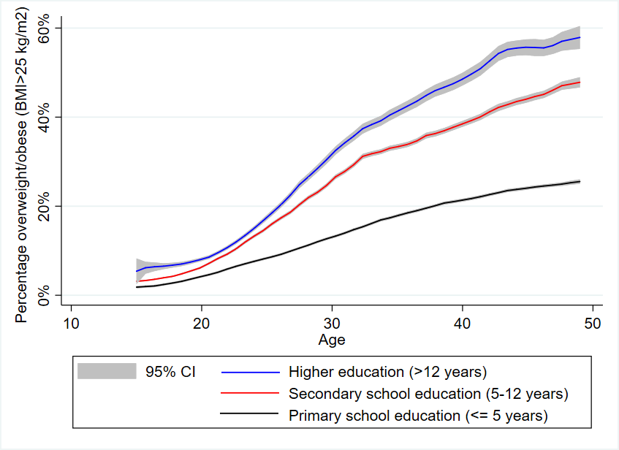
Figure 5: Relationship between overweight/obesity and type of occupation, conditional on age
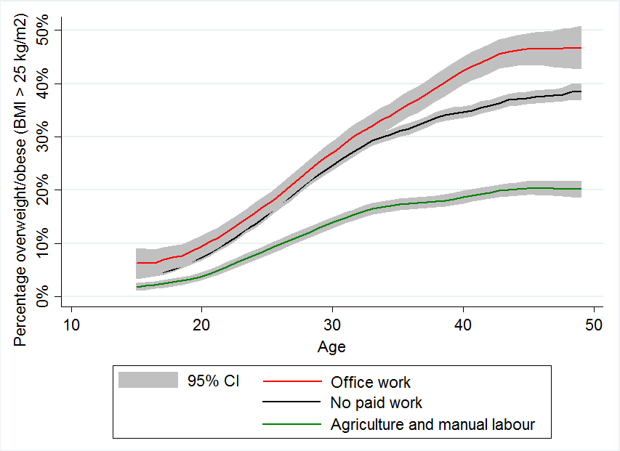

Next, we add controls for the mother’s years of education and type of occupation to the main percentile regressions reported in Table 1. We also control for the mother’s age, square of age, urban/rural residence, the household’s caste category, and the household’s religion. We present coefficients from these regressions in Table 3.
The impact of first child’s sex on BMI is still positive and statistically significant between the 30th to 70th percentiles of BMI. Interestingly, it is not statistically significant at the bottom two and top two BMI percentiles. It seems that education and occupation are more important than the first child’s sex as determinants of overweight/obesity for women who are either underweight, or obese.

Table 3: Relationship between first child’s sex and mother’s BMI - with controls for education and occupation
 | (1) | (2) | (3) | (4) | (5) | (6) | (7) | (8) | (9)
Variables | 10th percentile | 20th percentile | 30th percentile | 40th percentile | 50th percentile | 60th percentile | 70th percentile | 80th percentile | 90th percentile
First child is male | 0.037 | 0.012 | 0.084*** | 0.089*** | 0.070** | 0.063* | 0.098** | 0.055 | -0.002
 | (0.035) | (0.033) | (0.032) | (0.032) | (0.034) | (0.037) | (0.042) | (0.048) | (0.068)
Years of education | 0.098*** | 0.150*** | 0.178*** | 0.205*** | 0.236*** | 0.260*** | 0.281*** | 0.302*** | 0.334***
 | (0.010) | (0.010) | (0.010) | (0.010) | (0.011) | (0.011) | (0.013) | (0.015) | (0.021)
(Years of education)² | 0.001* | -0.002** | -0.003*** | -0.004*** | -0.006*** | -0.007*** | -0.008*** | -0.009*** | -0.010***
 | (0.001) | (0.001) | (0.001) | (0.001) | (0.001) | (0.001) | (0.001) | (0.001) | (0.001)
Type of occupation: (Base = No paid work)
Office work | 0.386*** | 0.273*** | 0.233*** | 0.186** | 0.209** | 0.171* | 0.104 | 0.043 | 0.024
 | (0.092) | (0.081) | (0.083) | (0.078) | (0.096) | (0.101) | (0.099) | (0.118) | (0.185)
Agriculture | -0.418*** | -0.460*** | -0.612*** | -0.713*** | -0.748*** | -0.790*** | -0.886*** | -0.958*** | -1.202***
 | (0.047) | (0.042) | (0.042) | (0.045) | (0.046) | (0.049) | (0.059) | (0.062) | (0.091)
Services | -0.049 | -0.008 | -0.120 | -0.169* | -0.082 | -0.015 | -0.045 | -0.113 | -0.127
 | (0.105) | (0.096) | (0.086) | (0.093) | (0.107) | (0.111) | (0.104) | (0.119) | (0.168)
Manual labour | -0.194*** | -0.290*** | -0.386*** | -0.435*** | -0.490*** | -0.539*** | -0.611*** | -0.659*** | -0.651***
 | (0.069) | (0.067) | (0.064) | (0.069) | (0.070) | (0.075) | (0.083) | (0.097) | (0.169)
Constant | 11.125*** | 11.133*** | 11.317*** | 11.295*** | 11.365*** | 11.558*** | 11.928*** | 11.633*** | 11.376***
 | (0.336) | (0.292) | (0.271) | (0.283) | (0.304) | (0.320) | (0.357) | (0.400) | (0.560)
Observations | 73,025 | 73,025 | 73,025 | 73,025 | 73,025 | 73,025 | 73,025 | 73,025 | 73,025
R-squared | 0.123 | 0.129 | 0.132 | 0.134 | 0.134 | 0.135 | 0.134 | 0.134 | 0.133
Note: Standard errors are clustered at the primary sampling unit level and are shown in parentheses. We also control for age, square of age, urban/rural residence, the household’s caste category, and the household’s religion in the above regressions. *** p<0.01, ** p<0.05, * p<0.1
- Results on mechanisms through which intrahousehold status may affect BMI
BMI increases when one eats more calorie-rich food and spends more time in sedentary activities. To check if improved status is associated with increased leisure consumption, we use information on the frequency of watching television (as a proxy for leisure in the absence of time-use data) in the NFHS. Frequent television watching is associated with higher BMI and a greater propensity for overweight and obesity (Dietz, 1993; L. Smith, Fisher, & Hamer, 2015).
We present results from linear probability models, where the dependent variable is a binary indicator of whether a woman watches TV frequently (Table 4). We find that women whose first child is male are more likely to watch TV frequently compared to women whose first child is female. We also control for education and occupation, since these factors are correlated with television-watching. More educated women are more likely to watch TV frequently. Similarly, women who work in offices are also more likely to watch TV frequently. The results are qualitatively similar in both urban and rural regions (not included in the table for the sake of brevity).
Another channel that can explain the positive correlation between intrahousehold status and BMI of women is higher consumption of calorie-rich foods by women who enjoy better status in their families.
We do not have good data on food consumption patterns of different members of households. The NFHS asks questions on the frequency of consumption of different food groups for women in sample households, but as mentioned earlier, this data is not reliable. The NSS-CES, however, collects data on the number of paid meals consumed in last 30 days by every member of the sampled households.
We explore the relationship between a woman’s status, as measured by daughter-in-law’s rank, and eating out behaviour using data from NSS-CES. Unfortunately, information on first child’s sex is not available in NSS-CES. We control for household fixed effects in this regression. We find that in patrilocal joint families, chhoti-bahus are significantly less likely to be eating out than badi-bahus (Table 5). The result is driven mainly by the urban sub-sample of joint families because eating out is quite uncommon in rural India. In 2011-12, only 2.4% people were eating out in rural India while 7.5% were eating out in urban India. Paid meals are only a small share of total calories consumed in India, but higher frequency of eating out by higher-ranked women in the family does hint at the possibility that such women may be eating richer food even at home. It also shows that improved status in the family may not necessarily lead to healthier diets. It may even be correlated with a higher consumption of more obesogenic foods.

Table 4: Relationship between intrahousehold status and frequency of watching television
 | (1) | (3)
Variables | Watch TV frequently | Watch TV frequently
First child is male | 0.004**
 | (0.002)
Years of education | 0.053*** | 0.051***
 | (0.001) | (0.001)
(Years of education)² | -0.002*** | -0.002***
 | (0.000) | (0.000)
Type of work: (Base = Agriculture)
No paid work |  | 0.014**
 |  | (0.007)
Office work |  | 0.021**
 |  | (0.010)
Services |  | 0.037***
 |  | (0.013)
Manual labour |  | 0.020*
 |  | (0.011)
Constant | 0.284*** | 0.277***
 | (0.018) | (0.021)
Control variables | Yes | Yes
Observations | 428,235 | 109,388
R-squared | 0.199 | 0.184
Note: Standard errors are clustered at primary sampling unit and are shown in parentheses.
*** p<0.01, ** p<0.05, * p<0.1

Table 5: Relationship between intrahousehold status and eating out
 | (1) | (2) | (3)
Dependent variable: Eating out | Total | Rural | Urban
Chhoti-bahu | -0.007** | 0.000 | -0.019***
 | (0.003) | (0.003) | (0.006)
Age | 0.001 | -0.002 | 0.007***
 | (0.001) | (0.001) | (0.002)
(Age)² | -0.000 | 0.000 | -0.000***
 | (0.000) | (0.000) | (0.000)
If any days away from home | 0.160*** | 0.118*** | 0.195***
 | (0.031) | (0.038) | (0.050)
If any other meals outside home | -0.130*** | -0.082** | -0.174***
 | (0.028) | (0.035) | (0.047)
Constant | -0.010 | 0.034** | -0.100***
 | (0.015) | (0.015) | (0.032)
Household fixed effects | Yes | Yes | Yes
Observations | 6,110 | 4,130 | 1,980
No. of households | 3,055 | 2,065 | 990
R-squared | 0.047 | 0.040 | 0.077
Note: Standard errors are clustered at primary sampling unit and are shown in parentheses.
*** p<0.01, ** p<0.05, * p<0.1

- Conclusions
This paper studies the role of intrahousehold status in explaining the high prevalence of overweight and obesity among women in India. We use exogeneous measures of intrahousehold status to causally estimate its relationship with BMI, finding that higher intrahousehold status leads to an increase in BMI.
Using quantile regression, we show that women whose first child is male have higher BMIs than women whose first child is female. The relationship is positive and statistically significant across all BMI percentiles. Thus, an increase in status increases BMI for women across all BMI percentiles, from those who are thin and normal weight, to those who are overweight or obese.
We also control for education and occupation in our regressions, as these are related to both intrahousehold status and BMI. Women who are more educated are more likely to be overweight/obese. Women who work in paid jobs in offices (i.e., in professional, technical, managerial, clerical, or sales jobs) are more likely to be overweight/obese than women who work in agricultural and manual labour. They are also more likely to be overweight/obese than women who are not engaged in any paid work.
Finally, controlling for education and occupation in our percentile regressions does not diminish the effect of first child’s sex on BMI for women within the 30th to 70th percentile BMI. At the two bottom-most and two top-most percentiles, education and occupation explain most of the variation in BMI, and the coefficient of the effect of first child’s sex is insignificant.
Our result is robust to an alternate exogeneous measure of intrahousehold status: daughter-in-law’s rank in patrilocal joint families. The higher ranked daughter-in-law has higher intrahousehold status and consequently higher BMI than the lower-ranked daughter-in-law.
We find evidence of two mechanisms via which status affects BMI in an obesogenic environment. First, higher status is associated with increased leisure consumption. Second, higher status is associated with a higher likelihood of eating out. Thus, improvement in women’s status does not necessarily lead to healthier lifestyles or healthier dietary habits.
We would expect that improved status or greater say in decision-making would lead us to take actions that are better for our health and wellbeing. Our analysis shows that this is not always the case. For a growing number of women in India, the improvement in status within the household may even be contributing to higher probability of being overweight. Could it be that these women do not know what is good for them? This does not seem to be the case. When we add an interaction term between sex of the first child and the educational attainment of the mother to the quantile regression shown in table 3, the coefficient is positive across the entire distribution of BMIs and statistically significant between the 30th and 70th percentiles of BMIs. The increase in BMI with improved status is not smaller for more educated women.
High BMI is the penalty a growing number of Indian women seem to be paying for improvements in their conditions (education, job profile, intrahousehold status, etc.). Reversing the positive correlation between status and body weight at the higher ends of the distribution of BMI may require special efforts to raise public awareness and improve the food environment.
References
Aziz, N., Kallur, S. D., & Nirmalan, P. K. (2014). Implications of the revised consensus body mass indices for asian indians on clinical obstetric practice. Journal of Clinical and Diagnostic Research, 8.
Bhalotra, S., Brulé, R., & Roy, S. (2018). Women’s inheritance rights reform and the preference for sons in India. Journal of Development Economics.
Bhalotra, S. R., & Cochrane, T. (2010). Where Have All the Young Girls Gone? Identification of Sex Selection in India. IZA Discussion paper.
Calvi, R. (2017). Why Are Older Women Missing in India? The Age Profile of Bargaining Power and Poverty. Retrieved from https://www.ssrn.com/abstract=3190369
Clark, S. (2000). Son Preference and Sex Composition of Children: Evidence from India. Demography, 37(1), 95.
Coffey, D., Khera, R., & Spears, D. (2015). Intergenerational effects of women’s status: Evidence from joint Indian households.
Coffey, D., & Spears, D. (2018). Child Height in India : Facts and Interpretations from the NFHS-4, 2015–16. Economic and Political Weekly, 53(31).
Dang, A., & Meenakshi, J. V. (2017). The Nutrition Transition and the Intra-Household Double Burden of Malnutrition in India.
Dietz, W. (1993). Television, Obesity, and Eating Disorders. Adolescent Medicine (Philadelphia, Pa.), 4(3), 543–550.
Eswaran, M., Ramaswami, B., & Wadhwa, W. (2013). Status, caste, and the time allocation of women in rural India. Economic Development and Cultural Change, 61(2), 311–333. https://doi.org/10.1086/668282
Gaiha, R., Jha, R., & Kulkarni, V. S. (2013). How Pervasive is Eating Out in India? Journal of Asian and African Studies, 48(3), 370–386. https://doi.org/10.1177/0021909612472040
Griffiths, P. L., & Bentley, M. E. (2001). The nutrition transition is underway in India. The Journal of Nutrition, 131(10), 2692–2700.
International Diabetes Federation. (2017). IDF Diabetes Atlas, Eighth edition. Retrieved from http://www.diabetesatlas.org/across-the-globe.html
International Institute for Population Studies. (2017). NFHS-4 (National Family Health Survey-4) India Fact Sheet.
Jha, P., Kesler, M. A., Kumar, R., Ram, F., Ram, U., Aleksandrowicz, L., … Banthia, J. K. (2011). Trends in selective abortions of girls in India: analysis of nationally representative birth histories from 1990 to 2005 and census data from 1991 to 2011. The Lancet, 377(9781), 1921–1928.
Joshi, K., Roy, D., Iannotti, L., Nagar, A., & Kishore, A. (2019). The effects of changing lifestyle and dietary patterns on obesity and non-communicable diseases in India.
Kishor, S., & Gupta, K. (2004). Women’s empowerment in India and its states: evidence from the NFHS. Economic and Political Weekly, 39(7), 694–712. https://doi.org/10.2307/4414645
Kishore, A., & Spears, D. (2014). Having a Son Promotes Clean Cooking Fuel Use in Urban India : Women ’ s Status and Son Preference. Economic Development and Cultural Change.
Klasen, S., & Pieters, J. (2012). Push or Pull? Drivers of Female Labor Force Participation during India’s Economic Boom.
Malapit, H. J. L., Kadiyala, S., Quisumbing, A. R., Cunningham, K., & Tyagi, P. (2013). Women’s empowerment in agriculture, production diversity, and nutrition: Evidence from Nepal.
Martorell, R., Khan, L. K., Hughes, M., & Grummer-Strawn, L. (2000). Obesity in women from developing countries. European Journal of Clinical Nutrition, 54, 247–252. https://doi.org/10.1038/sj.ejcn.1600931
Milazzo, A. (2018). Why are adult women missing? Son preference and maternal survival in India. Journal of Development Economics, 134, 467–484.
Misra, A., Singhal, N., Sivakumar, B., Bhagat, N., Jaiswal, A., & Khurana, L. (2011). Nutrition transition in India: Secular trends in dietary intake and their relationship to diet-related non-communicable diseases. Journal of Diabetes, 3(4), 278–292.
Nguyen, T. T., Adair, L. S., Suchindran, C. M., He, K., & Popkin, B. M. (2009). The association between body mass index and hypertension is different between East and Southeast Asians. The American Journal of Clinical Nutrition, 89(6), 1905–1912.
Patel, O., Shahulhameed, S., Shivashankar, R., Tayyab, M., Rahman, A., Prabhakaran, D., … Jaacks, L. M. (2017). Association between full service and fast food restaurant density, dietary intake and overweight/obesity among adults in Delhi, India. BMC Public Health, 18(1), 1–11. https://doi.org/10.1186/s12889-017-4598-8
Popkin, B. M., Adair, L. S., & Ng, S. W. (2012). The Global Nutrition Transition: The Pandemic of Obesity in Developing Countries. Nutrition Review, 70(1), 3–21.
Popkin, B. M., Horton, S., Kim, S., Mahal, A., & Shuigao, J. (2009). Trends in Diet, Nutritional Status, and Diet-related Noncommunicable Diseases in China and India: The Economic Costs of the Nutrition Transition. Nutrition Reviews, 59(12), 379–390.
Rao, N., Verschoor, A., Deshpande, A., & Dubey, A. (2010). Gender caste and growth assessment-India: Report to Department for International development.
Rosenblum, D. (2013). The effect of fertility decisions on excess female mortality in India. Journal of Population Economics, 26(1), 147–180.
Ross, K. L., Zereyesus, Y. A., Shanoyan, A., & Amanor-Boadu, V. (2015). The Health Effects of Women Empowerment: Recent Evidence from Northern Ghana. In International Food and Agribusiness Management Review (Vol. 18).
Seymour, G., & Peterman, A. (2018). Context and measurement : An analysis of the relationship between intrahousehold decision making and autonomy. World Development, 111, 97–112.
Smith, L. C., Ramakrishnan, U., Ndiaye, A., Haddad, L., & Martorell, R. (2002). The Importance of Women’s Status for Child Nutrition in Developing Countries.
Smith, L., Fisher, A., & Hamer, M. (2015). Television viewing time and risk of incident obesity and central obesity: the English longitudinal study of ageing. BMC Obesity, 2(1), 12.
Solomon, C. G., & Manson, J. E. (1997). Obesity and mortality: a review of the epidemiologic data. The American Journal of Clinical Nutrition, 66(4), 1044S-1050S.
WHO Expert Consultation. (2004). Appropriate body-mass index for Asian populations and its implications for policy and intervention strategies. The Lancet, 363(9403), 157–163.
World Health Organization. (2000). Obesity : preventing and managing the global epidemic : report of a WHO consultation. World Health Organization.

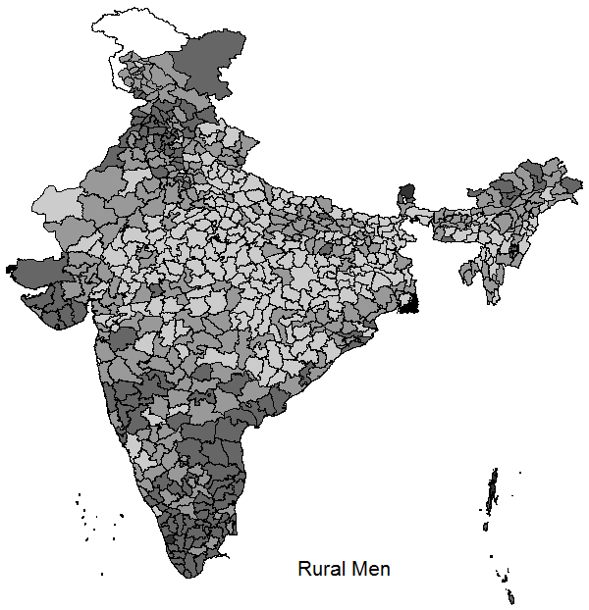
Appendix

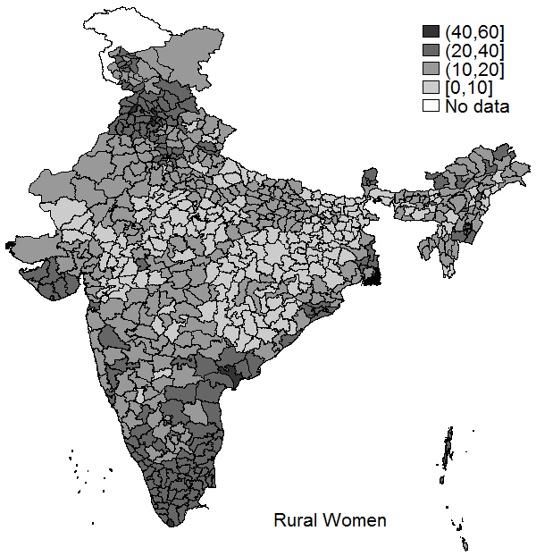
Figure A1: Overweight/obesity in districts of rural India in 2015-16 (in %)

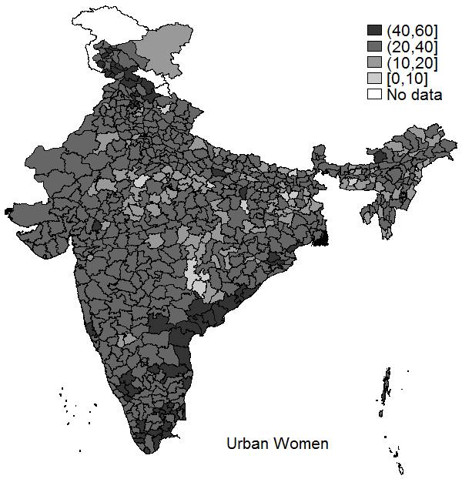
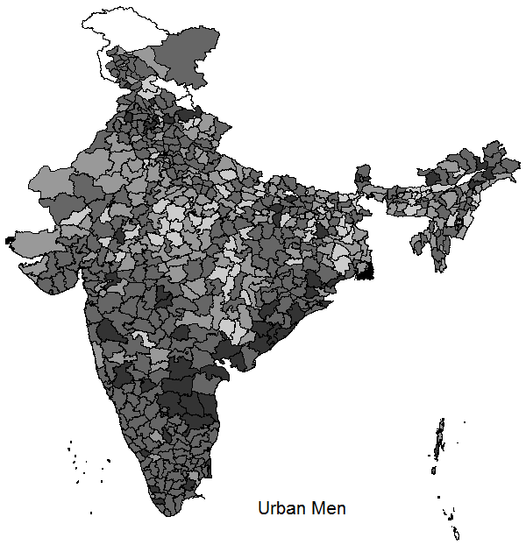
Figure A2: Overweight/obesity in districts of urban India in 2015-16 (in %)

Women who give birth to girls are also found to show fertility behaviours — like repeated and closely spaced pregnancies in attempts to have a son — which hurt their health and survival (Milazzo 2018).
We are aware that there might be other mechanisms at work and believe this topic merits further research facilitated by data on time-use.
The two surveys, NFHS-4 and NSS-CES were not conducted at the same time, but 2011-12 is the latest year for which NSS-CES data is available. Thus, we assume that the patterns in eating out have not changed sharply in the 4-5 intervening years.
Marrying at a young age is also associated with lower intrahousehold status in socio-economic literature (Kishor & Gupta, 2004). From the sub-sample of ever-married women in NFHS-4, we find that there is a positive relationship between age at first marriage and probability of overweight/obesity for the age range 0-35, after which there is a lot of noise in the data. The data on age at marriage in the NFHS-4 also has negative values, possibly due to recall bias. Considering the high error margin in this variable, we do not present results from regressions. However, with no additional control variables, we find a positive and statistically significant relationship between age at first marriage and BMI.
Using information on education from the same NSS-CES dataset, we also find that more educated women are more likely to be eating out.

