Threshold Effects of Corruption: Theory and Evidence

Niloy Bose^{a,} Salvatore Capasso^{b} and Antu Panini Murshid^{a,}♣
ªEconomics Department, University of Wisconsin-Milwaukee, Milwaukee, WI 53201,USA
^{b}University of Naples, Department of Economics, Via Medina 40, 80133 Napoli, Italy

July 16, 2006

Abstract
We examine the impact of corruption on the quality of public infrastructure. We propose a model in which private vendors supply governments with inputs necessary for the production of public goods. Asymmetric information between the two parties creates opportunities for vendors to earn profits. These profits can be re-distributed to government bureaucrats without impacting on the contractual form, as long as firms do not operate at a loss. Thus corruption adversely affects the provision of public goods only when it crosses a threshold. These results are examined in a sample of up to 125 countries. Consistent with our theory, we find strong evidence of a “corruption threshold.”

Key words: Corruption, government bureaucracy, infrastructure, public investment, threshold estimation.
JEL classification: C15, D73, H5,
- Introduction
Corruption is worse than prostitution. The latter might endanger the morals of an individual, the former invariably endangers the morals of the entire country—Karl Krauss.
Of course as economists the issue is not one of morality but simply that corruption is bad for development. Yet the rhetoric is equally charged—if not something “worse than prostitution,” corruption has been likened to a “cancer” on society. Such sentiments are grounded in strong theoretical foundations (Blackburn et. al., 2004; Sarte, 2000; Ehrlich and Lui, 1999; Bardhan, 1997; Krusell and Rios-Rull, 1996; Acemoglu, 1995) as well as a large empirical literature which finds that corruption lowers investment and growth (Serven et. al., 2005; Aghion et. al., 2004; Alesina et. al., 2003; Nicoletti and Scarpetta, 2003; Li et al., 2000; Tanzi and Davoodi, 1997; Mauro, 1996; De Soto, 1989). Accordingly a commitment to rooting out corruption is a critical part of any developmental strategy, although its complete elimination remains an unrealistic goal. This raises the question, is there some range over which corruption, though it exists, is benign, such that the costs normally associated with it only become apparent once a certain threshold is crossed? This is the question that we explore in this paper.
There are many reasons for believing why corruption is bad for development. Existing theory, while failing to be comprehensive, casts a wide net: stressing a variety of factors, from disincentive effects on capital investment, and innovation (e.g. Krusell and Rios-Rull, 1996), to the misallocation of talent into unproductive activities (e.g. Acemoglu, 1995). Our contribution is not to widen this “net” but simply recognize that the relationship between corruption and its associated costs is possibly non-monotonic. Importantly, such a hypothesis can be justified by means of a theoretical argument which is both simple and true under a reasonable set of assumptions. Supporting such a conclusion is also an empirical relationship between corruption and measures of inefficiencies which it generates that is surprisingly strong and robust.
The backdrop for our theory is public sector corruption. While this can take many forms, attention centers on corruption within government bureaucracies, i.e. when bureaucrats leverage their positions to further their own interests. To set the scene, consider a situation where a government procures inputs from firms in order to provide a public good. Inputs must meet certain quality standards. As an example, consider public infrastructure investments, such as the construction of roads, bridges or dams, which require inputs of cement of a certain quality. Public officials, or bureaucrats, are tasked with the objective of acquiring these inputs from firms in accordance with government-directives. However neither the government nor bureaucrats can distinguish good-quality cement from bad-quality cement. Under such circumstances, the government designs contracts so as to ensure that firms do not “cheat” by debasing the quality of cement. In particular the government pays a premium (to firms) above the costs of production. This provides firms with an opportunity to earn positive profits, some, or all of which, can be extracted by bureaucrats (in the form of bribes) who are the executors of government contracts. While these activities transfer income from firms to bureaucrats, firms, up to a point, will not renege on their contractual obligations by supplying cement of inferior quality. The provision of the public good is therefore not adversely affected. However, when the volume of corruption (as represented by the amount of bribes paid to bureaucrats) exceeds a certain threshold, this will no longer continue to hold true.
Our theory generates a testable implication. Namely, it points to the existence of a threshold, , below which the ill effects of corruption are not felt. Such effects are profound only when corruption exceeds this threshold. The theory on tests of parameter stability however is not well-developed although recently significant progress has been made in this direction by Hansen (2000) and Caner and Hansen (2004). The procedure involves two steps. First, it is necessary to identify the threshold at which the model parameters change. This is straightforward and in general involves minimizing a conditional loss function across different parameter-values for the threshold variable. However such a procedure will mechanically generate an estimate for , , and is not by itself a test of the null hypothesis that the model parameters are stable. That is allowing for non-monotonicity in the relationship between the dependent variable and its covariates is not a test of the threshold hypothesis. However testing such a hypothesis is non-trivial, since the threshold, , is unidentified under the null. This violates standard assumptions on which asymptotic properties of classical test-statistics are justified. Hansen (2000) however suggests a likelihood ratio test statistic, the distribution of which though non-standard, can be retrieved through a bootstrap procedure.
In this paper we provide empirical support for the main implications of our model by testing for threshold effects in the relationship between corruption and measures of the quality of public infrastructure investments using a procedure suggested in Hansen (2000). Our results, which are based on a large cross-section of countries, suggest two distinct regimes. One in which the incidence of corruption is high, and its effect on the quality of public infrastructure is strongly negative, and one for relatively low levels of corruption where the effect is neutral or perhaps even slightly positive. It is important to recognize that these threshold effects are not simply capturing the relationship between the quality of public infrastructure and the level of economic development. Threshold effects are apparent even when we control for various measures of development.
The remainder of this paper is organized as follows. In section 2, we present in detail our theoretical framework and its implications for the relationship between corruption and the quality of public investment. Section 3, describes the data and discusses our empirical methodology. In section 4, we present our results. Finally section 5 concludes.

- Theoretical Framework
  - The Environment
Below we present a simple partial equilibrium setup in which a government, or planner, provides a public good by procuring inputs necessary for its production. To contextualize our model, consider for instance a public project, such as the construction of a dam or a road, which utilizes large quantities of concrete. We assume that there are differences in the quality of inputs. Consider for instance the difference between cement, which is the most common type of concrete, and reinforced or prestressed concrete which can be subjected to far higher tensile forces. These differences are captured by assuming some variation in the marginal productivity of each input. In particular, suppose that that one unit of the high-quality input, input-, generates 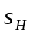 units of the public good, while one unit of the low-quality input, input-, yields 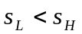 units of the good.
While cement has a variety of uses it should not be used for structures that are subjected to high tensile forces. This would typically require a type of concrete which has been reinforced or pre-stressed. Thus for instance, in the construction of roads, runways and or bridges, it is preferable to use at least some quantity of reinforced or prestressed concrete. Here we assume that the government wishes to build one of these structures, making it necessary to obtain high quality inputs,.
We assume also that low quality inputs, such as cement, are generic inputs. They have many alternative uses and as such they are readily available in the market at a competitive price. High quality inputs by contrast must be made to order and are not readily available from input markets. Again this is not unrealistic. Unlike cement, reinforced concrete and prestressed concrete must be pre-cast on the factory floor. They are therefore built to specifications. Cement however can simply be deposited in permanent fixtures as needed. Accordingly it is not unreasonable to expect cement to be relatively inexpensive to produce in contrast to reinforced concrete. Thus we assume that the marginal cost of producing , 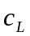, is lower than the marginal cost of producing , 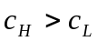.
  - The Government and Government Officials
We assume that the government’s objective is to maximize the provision of the public good subject to its resource constraint,. In order to achieve this, it designs a set of procurement rules (contracts) before handing over responsibility to a group of public officials or bureaucrats. Bureaucrats are charged with the task of procuring inputs subject to the rules set by the government. We assume that the government hires bureaucrats, where is proportional to the size of the project. The government pays each bureaucrat a wage,, which leaves an amount 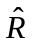 for procuring high-quality inputs. The government’s resource constraint is therefore given by: 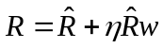 or equivalently,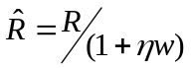, where 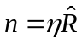.
  - Information
To the government and to bureaucrats a block of cement is indistinguishable from a block of reinforced concrete. Thus ex ante the quality of inputs supplied are the private information of firms. Since cement is cheaper to produce than reinforced concrete, suppliers of these inputs may have incentives to cheat by “passing-off” cement for reinforced concrete. However, in the event that firms supply low-quality inputs, with some probability, 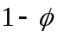, these actions may be detected. This may happen for instance, if structural deficiencies, depreciation, poor craftsmanship, and/or imperfections in the final good are revealed ex post. If this is the case, the supplier of the good can avoid prosecution by supplying the government the high-quality input as promised. The presence of moral hazard plays an important role in determining the procurement rules set by the government, which we discuss below.
  - Terms of Procurement under Asymmetric Information
Unlike generic inputs such as cement, which are traded in input markets, high quality inputs, such as reinforced concrete, are produced on a made-to-order basis. Consequently government contracts set both a price, 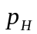, and a quantity 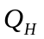. In the presence of informational asymmetry, the government designs the optimal contract by solving the following problem:
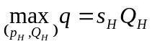 (1)
Subject to:
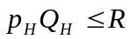 (2a)
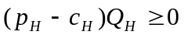 (2b)
(2c)
, 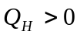 (2d)
Here can be interpreted as either the quantity of the public good, such as the length of roads in a country, or as a measure of quality, such as the average thickness of paved surfaces. The latter interpretation seems quite reasonable, since much of the distortionary effects of government bureaucracy and corruption are evident in the quality of public infrastructure. After all even corrupt countries can build roads connecting two points. Where the variation lies is in the overall quality of the final product.
Equation (2a) is simply the government’s resource constraint. The individual rationality constraint given by equation (2b), states that firms must be making non-negative profits, while the incentive compatibility constraint given in equation (2c) ensures that it is not in a firm’s best interest to supply low-quality inputs instead of high-quality inputs. The following proposition describes the optimal contract:
Proposition 1: If is small such that 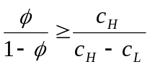, the optimal price-quantity vector, 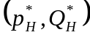, is given by:
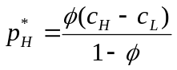, (3a)
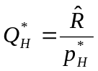. (3b)
Proof: See Appendix A.
The intuition behind this result is straightforward. A low value of ensures that there exists incentives for firms to cheat for positive values of . Now, in designing the optimal contract, the government must ensure that such cheating does not take place. At the same time, the government has no incentive to offer firms a price higher than what is required to deter cheating. This means that the incentive compatibility constraint (2c) must bind at the optimum, yielding the price, 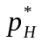. At the same time, the government must ensure that no resources are wasted. Accordingly, the resource constraint of the government, given in equation (2a), must also bind, which together with the value of pin down the optimal procurement quantity 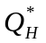.
Before we proceed further, it is important to highlight the role of informational asymmetry for our story. Consider a situation where the government has full information and is able to distinguish ex ante the quality of inputs while also controlling the actions of suppliers. Under such circumstances, the government can ensure that it receives type-H inputs, while also pulling down its offer price to the marginal cost of production, 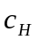. Consequently under full information the opportunity for firms to earn positive profits disappears. By contrast, under asymmetric information, the government must pay a premium above to ensure that the incentive compatibility constraint of firms is not violated. Consequently firms earn positive profits. This feature plays an important role in the derivation of subsequent results.
  - Threshold Effects in Corruption and Government Bureaucracy
In practice, procuring inputs is a complicated process involving several administrative procedures that are designed and vetted by bureaucrats. It is often the case that the bureaucrats misuse this power to their own advantage. For example, a corrupt bureaucrat can delay the registration process that firms must undergo to establish themselves as recognized government-vendors. Thus it is generally the case that the time needed to initiate business activities increases with the level of corruption (Figure 1). Alternately, bureaucrats may delay releasing payments to firms for its services and or goods provided. Since these actions are costly for firms, bureaucrats can demand bribes, , in exchange for eliminating these costs. The innovation of our analysis is to point out that negative effects of such illegal activities emerge only when the volume of bribe exceed a particular threshold. Proposition 2 states this result precisely.
Proposition 2:
- There exists a threshold , where
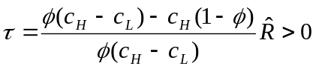 (4)
such that for all 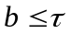, is unaffected.
- For all 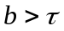, 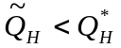 and 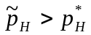, where 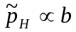 and 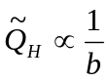.
Proof: See Appendix A.
Again the intuition behind this result is simple. Note that the bribe extracted by bureaucrats acts like a lump-sum tax on firms; it raises the costs of production and it does so irrespective of whether firms produce low-quality or high-quality inputs. Bribes therefore have implications for firms’ individual rationality (participation) constraints, but not for their incentive compatibility constraints. This matters because for the original contract , the binding constraint is not the individual rationality constraint but rather the incentive compatibility constraint. Thus, as long as the participation constraint is satisfied, bureaucrats can extract bribes without affecting their supply decisions. This establishes the existence of a threshold level of bribes, , for which the participation constraint holds with equality for the pair .
Suppose however that bribes paid to bureaucrats exceeds the threshold, . Also, suppose that the government recognizes this corruption and takes this into account when designing the optimal contract. Clearly, since firms will no longer break-even at a price 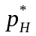, the government is forced to offer a higher price 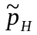. Given the limited size of government budgets, this translates into a lower quantity, 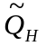, which the government can now afford to purchase from firms. These observations corroborate with reality. As a result of excessive corruption, inflated cost of public expenditure co-exists with the low quality of existing public infrastructures in many countries (Gupta et. al., 2000; Tanzi and Davoodi, 1997).
One may however, argue that the government need not take as given, the corruption within its bureaucracy. Instead it may wish to deter corrupt practices by implementing a monitoring technology. Such technologies however are likely to be costly, reducing resources available for providing public goods. Thus excessive corruption would, in any event, adversely affect the provision of public goods.

- Data and Methodology
  - Methodology
Our theory has straightforward and testable implications. Corruption within government bureaucracies can lower the quantity or quality of public investments. At the same time the possibility exists for these failures to have no ill-effects. Which of these outcomes correctly describes the relationship between government failures and public investment, will depend on the extent of corruption. We can describe these relationships more formally as follows:
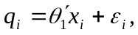 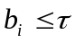 (5a)
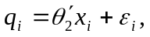 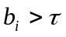 (5b)
here 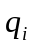 measures the volume or quality of public investments, in country , 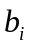 is a threshold variable, corresponding to the amount of bribes paid to bureaucrats to sidestep regulatory obstacles and  is a set of controls.
This specification is quite general in that it imposes no cross-regime restrictions on our parameters. However since our focus is on how the effect of corruption changes, it will be useful to restrict some, or all, other model parameters. While a continuous spline specification may be too restrictive, ideally we would want to allow the coefficient on our corruption index as well as the constant term to change. Formally, we would want to estimate the following specification:
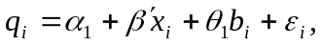 (6a)
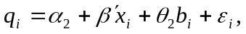 (6b)
and are as above, is re-defined as the set of control variables excluding .
Equations (6a) and (6b) reduce to a single equation:
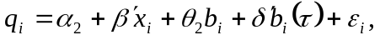 (7)
where 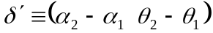, 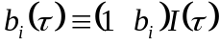, and 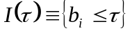 is an indicator variable. Note that for any given , (7) is linear in its parameters, thus the simplest way to estimate is through conditional least squares (Hansen, 2000). This involves choosing so as to minimize 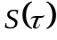, where is the sum of squared residuals for any given value of .
In order to test the statistical significance of a threshold effect typically we would want to test the null hypothesis of “no threshold effect,” i.e. 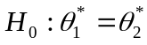, where 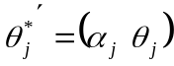 for 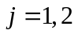. However, since is only identified under the alternative, the distributions of classical test statistics, such as the Wald and likelihood ratio tests, are not asymptotically chi-squared. In essence this is because the likelihood surface is flat with respect to , consequently the information matrix becomes singular and standard asymptotic arguments no longer apply. There are methods for handling hypothesis testing within these contexts. In some instances, we are able to bound the asymptotic distribution of likelihood ratio statistics (Davies, 1977 and 1987), alternatively their asymptotic distribution must be derived by bootstrap methods. Hansen (2000) proposes the later. The appropriate test statistic is:
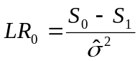,
where 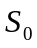 and 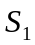 are, respectively, the residual sum of squares under the null hypothesis and the alternative 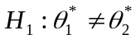, and 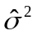 is the residual variance under the alternative 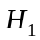.
In the presence of heteroscedasticity a “wild bootstrap” is preferable to standard residual bootstrapping (Wu, 1986; Davidson and Flachaire, 2001). This is done in a number of stages. First, by transforming the residuals, , from our regression analysis using the following transformation: 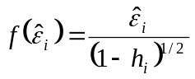, where 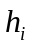 is the ^{th} diagonal of the projection matrix 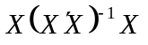 and 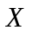 is simply our matrix of regressors in (7), i.e. 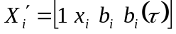. Next, we generate 999 replications of the random error, 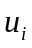, where
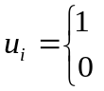 with probability ½
with probability 0
Finally we can use the transformed residuals, 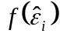, and the bootstrap errors, , to create a bootstrap sample under the null as follows:
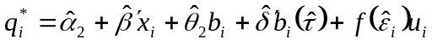.
When threshold effects are present, is consistent (Hansen, 2000). However in discontinuous threshold regression models, the asymptotic distribution of is non-standard. Hansen (2000) proposes calculating confidence intervals by forming a “no-rejection region” based on likelihood ratio tests on . Specifically we would want to test the null: 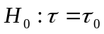, rejecting for large values of 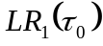, where
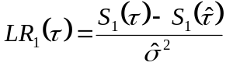.
Hansen (2000) has derived the asymptotic distribution of , which while non-standard, requires little additional computation.
Below we apply these methods to estimate the effect of corruption on measures of the quality of public infrastructure in a cross-section of countries.
  - Data
As our dependent variables, we use three measures of the quality of public infrastructure. In all instances data on our quality measures are available over a ten-year period from 1990-2000. Accordingly our analysis is based on decadal averages, however generally much of the variation within the sample is across countries. Country-coverage is varied however in some simple specifications, our sample covers up to 125 countries. Below we discuss our measures of quality, as well as the variables we use to measure corruption. Our measures of the quality of public infrastructure are drawn from a database recently compiled by Estache and Goicoechea (2005). These data present in a single source data drawn from a variety of publicly available sources including the International Energy Agency, World Health Organization, and World Development Indicators. In this paper, we consider three measures of the quality of public infrastructure. These include a measure the quality of electricity generation and its distribution, the quality of roads, and the quality of water supply.
The quality of electricity is measured as the percent of electricity generated that is successfully distributed. This variable is calculated using data on electric power transmission and distribution losses as a percent of total power generated, averaged between 1990 and 2000. Power losses include electricity lost in its generation and delivery, as well as those caused by unmetered supply.
We use a measure of the length of paved road surfaces (normalized by country size) as a measure of the quality of the road network. Data on this variable are available from 1990. We take the ten-year average from 1990 to 2000. An alternative measure of the quality of roads is the percent of road surfaces that are paved. However this measure is often problematic. In particular in larger countries, often substantial parts of the road network are not paved. As a result, according to this measure, the road network in Bhutan (along with 67 other countries in our sample for which we have data) is superior to that in the United States.
Finally, as our measure of the quality of water supply, we use data on the percent of the population with access to improved water sources. Data on this variable are available from 1990. Again we take a ten-year average between 1990 and 2000. This measure is more a measure of size, rather than quality of water supply technologies. Unfortunately data on variables such as water losses, leaks and water quality are simply not available for a sufficiently large sample of countries to make this a viable alternative.
Our measure of corruption is based on Transparency International’s corruption perception index. The index is appropriately redefined so that it varies between 0 and 10, where higher values are associated with higher levels of corruption. Unfortunately the earliest date for which these data are available is 1995. We therefore measure corruption as the average value of this index between 1995 and 2000. If data within this period are not available, we take the earliest year for which data are available.
Our other explanatory variables include controls for the level of development and institutional quality—these are initial per-capita GDP, secondary school enrollment ratios, the number of telephone mainlines, and an index of government effectiveness. We also control for population density. This variable captures the fact that in countries with low population densities larger investments are needed per household to provide or maintain a certain quality of service from public infrastructure. Thus for instance, we often find that the quality of roads connecting rural areas are of an inferior quality to roads in urban areas. Finally we introduce controls for government deficits and country openness. These variables aim to capture the effect of government budgetary issues on public infrastructure quality. The effect of deficits on public infrastructure spending is obvious, however country openness may also matter since a large tradable goods sector can imply a steady and larger tax base for governments.

- Results
We begin our analysis by estimating a simple benchmark specification where we regress decadal averages of the quality of public infrastructure, against logs of initial real per-capita income and our corruption index. At this stage we do not attempt to introduce additional controls and moreover we impose the assumption of linearity on our model-specification (Table 1). Not unexpectedly, per-capita income in 1990 is found to be strongly correlated with the quality of public infrastructure. However corruption only has a negative effect on the quality of electricity and roads, and even then the result is only statistically significant in one case. As our analysis below suggests, at least in part, this could be due to the presence of strong threshold effects.
In Table 2, we consider the possibility of threshold effects. The table is divided into two panels. Panel A allows all model parameters to change when corruption crosses a particular threshold. This specification therefore corresponds to equations (5a) and (5b). The model in Panel B restricts the coefficient on per-capita income to be constant across both regimes. This is effectively the specification described in equations (6a) and (6b) (alternatively equation 7). Our analysis points to the presence of strong threshold effects. In most cases the null hypothesis can be rejected at least at the five percent level. Some of the variation within the data is captured by parameter instability in the coefficient on income (Table 2, Panel B). However, in most instances, the association between per-capita incomes and the infrastructure-quality remains positive and statistically significant across both regimes. This is not the case, for the corruption index. The coefficient on corruption changes abruptly across the two regimes. While corruption usually shows no association, or even a positive association, with infrastructure-quality in the low-corruption regime, this relationship turns sharply negative once the value of corruption crosses a particular threshold. Moreover, in each instance this negative effect of corruption is highly statistically significant.
It is important to recognize that even when we restrict the coefficient on income to be constant across regimes these conclusions are largely unaffected. Evidently much of the cross-regime variation in our data can be explained by the instability in the corruption index. This is clearly evident in plots of the partial correlations between our three quality measures and the corruption index (Figure 2). The sharpest threshold effects are evident in the relationship between corruption and the quality of electricity and water supply. By contrast, the variation within the data is less dramatic when we focus on measures of road-quality.
It is worth noting that for each of our quality measures, the thresholds occur at different levels. The threshold is particularly low when quality is measured as the length of paved roads surfaces, occurring at a value of roughly 1.4 for the (log) corruption index. This corresponds to countries in the 20th percentile with respect to corruption within their economies. By contrast, the cut-off is much higher when our quality measure is the percent of the population with access to improved water. Roughly 60 percent of the countries for which corruption data are available belong to the first regime where corruption has no ill effects.
The variation in the cut-off points at which corruption has harmful effects is perhaps not surprising. After all our measures of corruption and government regulations are aggregated. The level of corruption in road-construction need not be similar to that observed in power-generation industries. Since data on corruption are not available on an industry-by-industry basis, we cannot test whether corruption thresholds are similar across industries. However, even if disaggregated data were available, there is no reason why we should expect the thresholds to be the same across different industries. Our theory for instance suggests that differences in industry-profitability are potentially important determinants of the extent to which corruption and government regulations matter.
In Tables 3-5, we extend our analysis by introducing a variety of other controls. These include secondary school enrollment ratios, the number of telephone mainlines, a measure of institutional quality, population densities, the size of government balances and a measure of trade openness.
The inclusion of these additional controls provides some insights into other determinants of the quality of infrastructure. For instance, we find that the relationship between infrastructure-quality and measures of development and institutional quality, are generally positive, although a significant degree of co-movement across these variables makes it difficult to isolate these relationships in specifications that include all of these measures simultaneously. Thus for instance, the number of telephone mainlines appears to capture more of the variation in our data on the quality of electricity than either income or schooling, which though positively associated with electricity-quality are typically not statistically significant. By contrast the important determinant vis-à-vis the quality of water supply appears to be institutional quality, while all other proxies for development are essentially uncorrelated.
Population density also appears to matter, at least for the quality of road networks. The relationship appears to be negative, however it is strongly quadratic. Thus in general increases in population density are associated with improvements in the quality of roads, which is intuitive. By contrast, once we account for threshold effects, government budgetary issues, as measures by the size of government budget deficits and our openness variable are not important determinants of the cross-sectional variation in infrastructure-quality.
Within the current context the important result is that the inclusion of additional controls does not affect the underlying conclusion that threshold effects are present. This conclusion is strongest when quality is measured as the percent of total electricity successfully distributed from source to destination; it is weakest when quality is measured as the length of paved road surfaces. In part, this could be because our data on the road-quality is so noisy, hence a threshold, if it is present, is more difficult to isolate. Even so a conclusion that threshold effects are present is not without merit. The results are certainly suggestive, if not always statistical significant. By contrast there is relatively strong evidence to suggest the presence of corruption thresholds when infrastructure quality is measured either in terms of access to water supply or electricity distribution. Sensitivity analyses (not shown here) revealed these results to be robust to various other specification changes which involved including additional controls for institutional quality, as well as controls for the black market premium and the country-size. Moreover evidence of threshold effects were found in a sub-sample that excluded all developed countries, as well as in samples that centered on specific groups of developing countries categorized by income.
Some sensitivity using a GMM-estimation procedure suggested by Camer and Hansen (2004) continued to support our underlying conclusions. In Camer and Hansen (2004) the asymptotic arguments are essentially those in Hansen (2000), however the method for estimating the threshold, , is different. The estimation strategy suggested deals with the potential endogeneity of left hand side variables, however critically it does not account for the endogeneity of the threshold variable. Given our focus on infrastructure-quality, our hope was that this would not be much of an issue. While reverse-causality would be a problem if we were considering the effect of corruption on broader macroeconomic aggregates, such as the rate of growth, it is not immediately apparent why an unpaved road surface, or “load sharing” and blackouts, should have implications for the corruption of public officials. It is nevertheless possible that our measures of infrastructure-quality are correlated with other institutional variables, which in turn are correlated with corruption. To some extent we can hope to mitigate this source of bias by introducing controls for the level of development which we have attempted to do. Essentially therefore we have tried to sidestep the issue of endogeneity, rather than dealing with it head on. This however remains difficult on the basis of existing theory.

- Conclusions
The view that governance matters has, in recent years, gained increasing acceptability within the development community. Amongst other things, this has meant an increasing scrutiny of corrupt practices within government bureaucracies. The bases for these new directions in policy making are not uncertain. The evidence that corruption is bad for development is both convincing and robust. As such the conventional wisdom is that corruption should be rooted out wherever and whenever it is found to exist.
However such a view assumes that the returns to lowering corruption are, at the margin, greater than the costs of doing so. It is far from obvious that this will always be the case. We can therefore reasonably speculate as to the existence of an optimal level of corruption. It is however difficult to say much more without being precise about the nature of anti-corruption technologies.
In this paper our goal is not to confront these issues head-on. Instead our focus has been on developing a better understanding of the costs associated with corruption. We conjecture that the costs of corruption do not increase monotonically and such costs are only evident when the level of corruption exceeds a certain threshold level. We demonstrate that such a hypothesis is both reasonable and consistent with data, and anticipate that such information would prove to be valuable in designing policies to combat corruption in an efficient manner.
APPENDIX A
Proof of Proposition 1
Let 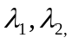and 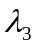denote the multipliers associated with the constraints (2a), (2b) and (2c) respectively. Accordingly we write the first order conditions as:
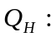 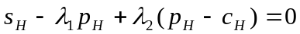 (A1)
: 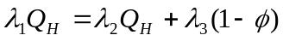 (A2)
First note that Equation (A1) implies that 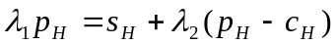. Since, 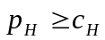 and 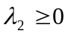, we have 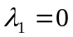. Next, if 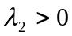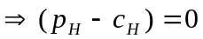. This would violate the incentive compatibility constraint (2c) as 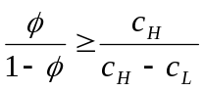. Accordingly, 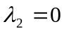. Finally, since 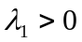 and , equation (A2) implies 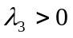. Given 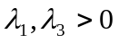, the solution 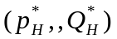 must satisfy equations (2a) and (2c) taken as equality. This implies, and .

Proof of Proposition 2
(i) First note that, given , a firms profits are 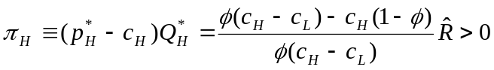. Next, since red tape is imposed on firms irrespective of what it supplies, the incentive compatibility constraint of firms (equations 2c) is unaltered. Also, for a given , the resource constraint of the government (equation 2a) remains unchanged. However, a bribe, must now be subtracted from the L.H.S. of equation (2b). This does not, however, alter the first order conditions as given by equations (A1)-(A2). Now, let be the minimum value of for which 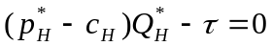. Thus, for any 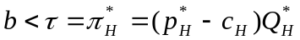 equation (2b) holds with strict inequality implying that . Since is still valid, the solution will still be the same as given in Proposition 1.

(ii) To ensure that 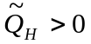, the relation 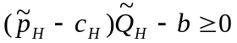must hold. Since,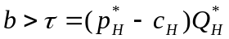, it must be that
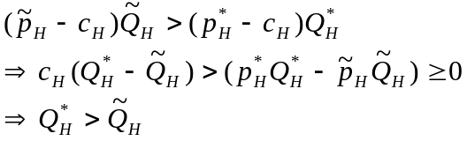
Further, since 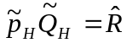, we have . Recall that inclusion of bribes leaves the first order conditions (equations A1 and A2) unchanged. Since, , equation (A2) implies either 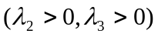or 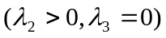or 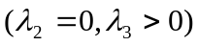. Since, , we have 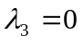. Therefore, the solution must satisfy 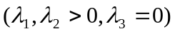. Accordingly, the solution is given by 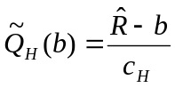 implying that decreases monotonically with the level of red tape.
APPENDIX B
Table B.1. Descriptions of Variables and Data Sources:
Variable | Description
 | Dependent Variables
Quality of electricity = [100-Electric power transmission and distribution losses (% of total output)]/100.
Electric power transmission and distribution losses are technical and non-technical losses, this comprises all losses due to transport and distribution of electrical energy and heat, which include losses in transmission between sources of supply and points of distribution and in the distribution to consumers, including pilferage. Estache and Goicoechea (2005), original sources WB Energy Team, World development Indicators.
Quality of roads = log(length of paved road surfaces).
Length of paved road surfaces is calculated as the product of the percent of paved roads and road density, which is the total road network in km divided by the total land area in sq km. Estache and Goicoechea (2005), original sources International Road Federation, World Road Statistics.
Quality of water = Access to improved water sources as a fraction of total population.
“Improved” water supply technologies are: household connection, public standpipe, borehole, protected dug well, protected spring, rainwater collection. Availability of at least 20 liters per person per day from a source within one kilometer of the user's dwelling. “Not improved” are: unprotected well, unprotected spring, vendor-provided water, bottled water (based on concerns about the quantity of supplied water, not concerns over the water quality), and tanker truck-provided water. Estache and Goicoechea (2005), original sources, World Health Organization, United Nations Children's Fund, JMP report (2004).
 | Explanatory Variables
Corruption index = log(10-Corruption Perceptions Index)
Corruption perceptions index is an index of corruption varying between 0 and 10, with higher values corresponding to lower levels of corruption. Transparency International.
Initial real GDP = log real GDP per capita in 1990, measures in 1990 dollars. World Development Indicators.
Schooling = Secondary school enrollment ratio. World Development Indicators.
Phones = log(Telephone mainlines per 1000 people). World Development Indicators.
Government effectiveness
= Index based on perceptions of the quality of public service, bureaucracy, civil servants, and the independence of civil servants from political pressures. The focus of this index is on “inputs” required for the government to implement good policies. For more details see Kaufmann et al. (2002).
Population density = log[population density (people per square km)]. The variable population density² is the square of the log of population density. World Development Indicators.
Government balance = Overall deficit / surplus as % of GDP. Government Finance Statistics.
Trade = Ratio of exports + imports to GDP. World Development Indicators.

REFERENCES
Acemoglu, D. (2001), “Reward Structures and the Allocation of Talent,” European Economic Review 39(1), 17-33.
Acemoglu, D. and Verdier, T. (2000), “The Choice Between Market Failures and Corruption,” American Economic Review 90(1), 194-211.
Alesina, A., Devleeschauwer, A., Easterly, W., Kurlat, S. and Wacziarg, R. (2003). “Fractionalization,” Journal of Economic Growth, 8(2), 155-194.
Aghion, P., Alesina, A. and Trebbi, F. (2004). “Endogenous Political Institutions,” Quarterly Journal of Economics, 119(2), pp. 565-611.
Bardhan, P. (1997). “Corruption and Development: A Review of Issues,” Journal of Economic Literature 35(3), 1320-1346.
Blackburn, K., Bose, N. and Haque, M. E. (2004). “Endogenous Corruption in Economic Development,” University of Nottingham Working Paper No. 2004/16.
Ehrlich, I. and Lui, F. T. (1999). “Bureaucratic Corruption and Endogenous Economic Growth,” Journal of Political Economy 107(S6), S270-S293.
Caner, M. And Hansen, B. E. (2004). “Instrumental Variable Estimation of a Threshold Model,” Econometric Theory 20(5), 813-843
Chan, K. S. and Tsay, R. S. (1998). “Limiting Properties of the Least Squares Estimator of a Continuous Threshold Autoregressive Model.” Biometrika 85, 413-426.
Davidson, R., and Flachaire, E. (2001). “The Wild Bootstrap, Tamed at Last,” GREQAM Document de Travail 99A32.
Davies, R. B. (1977). “Hypothesis Testing When a Nuisance Parameter is Present Only Under the Alternative,” Biometrika 64(2), 246-254.
__________. (1987). “Hypothesis Testing When a Nuisance Parameter is Present Only Under the Alternative, Biometrika 74(1), 33-43.
De Soto, H. (1989). The Other Path, New York, NY: Harper and Row.
Estache, A. and Goicoechea, A. (2005). “A 'Research Database on Infrastructure Economic Performance,” World Bank Policy Research Working Paper No. 3643.
Gupta, S., Davoodi, H. and Tiongson, E. (2000), “Corruption and the Provision of Health Care and Education Services”, IMF Working Paper, WP/00/116.
Hansen, B. E. (2000): “Sample Splitting and Threshold Estimation,” Econometrica 68(3), 575-603.
Kaufmann, D., Kraay, A. and Zoido-Lobaton, P. (2002). “Governance Matters II: Updated Indicators for 2000/01.” World Bank Policy Research Working Paper No. 2772.
Krusell, P. and Rios-Rull, J.-V. (1996). “Vested Interests in a Positive Theory of Stagnation and Growth,” The Review of Economic Studies 63(2), 301-329.
Li, H., X. L. C., and Zou. H.-F. (2000). “Corruption, Income Distribution, and Growth.” Economics and Politics 12(2), 155-82.
Mauro, P. (1996). “Corruption and Growth,” Quarterly Journal of Economics 110(3), 681-712.
Nicoletti, G., and Scarpetta, S. (2003). “Regulation, Productivity, and Growth: OECD Evidence,” World Bank Policy Research Working Paper No. 2944.
Sarte, P. D. G. (2000). “Informality and Rent-Seeking Bureaucracies in a Model of Long-Run Growth,” Journal of Monetary Economics 46(1), 173-197.
Serven, L., Oviedo, A. M. and Loayza, N. V. (2005). “Regulation and macroeconomic performance,” Policy Research Working Paper Series 3469, The World Bank.
Tanzi, V., and Davoodi, H. (1997). “Corruption, Public Investment and Growth,” IMF Working Paper No. 97/139.
Wu, C. F. J. (1986). “Jackknife, Bootstrap and Other Resampling Methods in Regression Analysis,” Annals of Statistics 14(4), 1261–1295.
Table 1: Impact of Corruption on the Quality of Public Infrastructure: Simple OLS
 | Quality of Electricity | Quality of Roads | Quality of Water
Independent variable | (1) | (2) | (3)
Constant | 0.7151 | -1.2623 | 0.0249
 | (0.0624) | (0.6985) | (0.1339)
Income | 0.0233 | 0.2557 | 0.0979
 | (0.0060) | (0.0584) | (0.0137)
Corruption | -0.0260 | -0.1411 | 0.0261
 | (0.0099) | (0.2057) | (0.0204)
Observations | 105 | 125 | 105
R² | 0.35 | 0.25 | 0.46

Notes: Both initial GDP and the corruption index are measured in logs. Standard errors are reported in parentheses. A full description of all variables is offered in Appendix B.
Table 2: Threshold Effects in Corruption
 | Quality of Electricity |  | Quality of Roads |  | Quality of Water
Panel A
 | Regime 1 | Regime 2 | Regime 1 | Regime 2 | Regime 1 | Regime 2
 | corruption <= 1.7538 | corruption > 1.7538 | corruption <= 1.3987 | corruption > 1.3987 | corruption <= 1.9320 | corruption > 1.9320
 | (1a) | (1b) | (2a) | (2b) | (3a) | (3b)
constant | 0.7068 | 1.9601 | 0.6455 | 0.0361 | 0.0690 | 3.2949
 | (0.0455) | (0.2520) | (5.9433) | (0.3962) | (0.1750) | (0.7702)
Income | 0.0227 | -0.0097 | 0.0569 | 0.1034 | 0.0926 | 0.1013
 | (0.0045) | (0.0075) | (0.5888) | (0.0226) | (0.0178) | (0.0213)
Corruption | 0.0020 | -0.5495 | 0.6434 | -0.3048 | 0.0251 | -1.5964
 | (0.0046) | (0.1175) | (0.3419) | (0.1545) | (0.0226) | (0.3700)
Threshold | 1.7538 |  | 1.3987 |  | 1.9320
95 % CI | (1.7108, 1.8299) |  | (1.1632, 1.1.4563) |  | (1.8728, 2.0477)
Bootstrap p-value | (0.00) |  | (0.28) |  | (0.03)
Observations | 105 |  | 125 |  | 105
Joint R² | 0.55 |  | 0.41 |  | 0.55
Panel B
 | Regime 1 | Regime 2 | Regime 1 | Regime 2 | Regime 1 | Regime 2
 | corruption <= 1.7538 | corruption > 1.7538 | corruption <= 1.3987 | corruption > 1.3987 | corruption <= 1.9320 | corruption > 1.9320
Constant | 0.9340 | 1.8286 | 0.2191 | 0.0885 | 0.0356 | 3.3525
 | (0.0570) | (0.2264) | (0.6544) | (0.7583) | (0.0135) | (0.7493)
Income | 0.0000 | 0.0000 | 0.0998 | 0.0998 | 0.0960 | 0.0960
 | (0.0057) | (0.0057) | (0.0499) | (0.0499) | (0.1330) | (0.0135)
Corruption | -0.0171 | -0.5165 | 0.6595 | -0.3190 | 0.0297 | -1.6080
 | (0.0069) | (0.1070) | (0.3777) | (0.2330) | (0.0183) | (0.3688)
Threshold | 1.75 |  | 1.40 |  | 1.93
95 % CI | (1.6658 , 1.8550) |  | (1.3971 , 1.4563) |  | (1.8769 , 2.0477)
Bootstrap p-value | (0.00) |  | (0.05) |  | (0.02)
Observations | 105 |  | 125 |  | 105
Joint R² | 0.53 |  | 0.41 |  | 0.55

Notes: Both initial GDP and the corruption index are measured in logs. A full description of all variables is offered in Appendix B. Standard errors are in parentheses, except bootstrap p-value and confidence intervals around estimated thresholds, which are also reported in parentheses. Bootstrap p-values were generated on the basis of 999 iterations (see text for details). Estimation was performed using a code written by the authors for Gauss. The code is available on request.

Table 3: Threshold Effects in the Relationship between Corruption and the Quality of Electricity: General Specification
Quality of Electricity
 | Regime 1 | Regime 2 | Regime 1 | Regime 2 | Regime 1 | Regime 2
 | corruption <= 1.7440 | corruption > 1.7440 | corruption <= 1.7440 | corruption > 1.7440 | corruption <= 1.7440 | corruption > 1.7440
 | (1a) | (1b) | (2a) | (2b) | (3a) | (3b)
Constant | 0.9385 | 1.8296 | 0.9403 | 1.7395 | 0.9063 | 1.8162
 | (0.0848) | (0.2314) | (0.0825) | (0.2156) | (0.0895) | (0.2610)
Income | -0.0013 | -0.0013 | -0.0092 | -0.0092 | 0.0060 | 0.0060
 | (0.0146) | (0.0146) | (0.0152) | (0.0152) | (0.0196) | (0.0196)
Schooling | -0.0053 | -0.0053 | -0.0082 | -0.0082 | -0.0002 | -0.0002
 | (0.0452) | (0.0452) | (0.0445) | (0.0445) | (0.0004) | (0.0004)
Phones | 0.0022 | 0.0022 | 0.0056 | 0.0056 | -0.0111 | -0.0111
 | (0.0141) | (0.0141) | (0.0137) | (0.0137) | (0.0156) | (0.0156)
Government effectiveness |  |  | 0.0310 | 0.0310 | 0.0408 | 0.0408
 |  |  | (0.0146) | (0.0146) | (0.0217) | (0.0217)
Population |  |  |  |  | -0.0075 | -0.0075
 |  |  |  |  | (0.0160) | (0.0160)
Population² |  |  |  |  | 0.0008 | 0.0008
 |  |  |  |  | (0.0016) | (0.0016)
Government balance |  |  |  |  | -0.1613 | -0.1613
 |  |  |  |  | (0.2045) | (0.2045)
Trade |  |  |  |  | -0.0084 | -0.0084
 |  |  |  |  | (0.0088) | (0.0088)
Corruption | -0.0172 | -0.5144 | -0.0003 | -0.4386 | 0.0033 | -0.4948
 | (0.0076) | (0.1023) | (0.0103) | (0.0951) | (0.0117) | (0.1158)
Threshold | 1.7440 |  | 1.7440 |  | 1.7440
95 % CI | (1.6658, 1.8550) |  | (1.7108, 1.8769) |  | (1.7440 , 1.7440)
Bootstrap p-value | (0.00) |  | (0.01) |  | (0.03)
Observations | 104 |  | 104 |  | 73
Joint R² | 0.53 |  | 0.55 |  | 0.62

Notes: The variables initial GDP, corruption, phones, population and population² are measured in logs. The variables population² is the square of log of population density. A full description of all variables is offered in Appendix B. Standard errors are in parentheses, except bootstrap p-value and confidence intervals around estimated thresholds, which are also reported in parentheses. Bootstrap p-values were generated on the basis of 999 iterations (see text for details). Estimation was performed using a code written by the authors for Gauss. The code is available on request.

Table 4: Threshold Effects in the Relationship between Corruption and the Quality of Roads: General Specification
Quality of Roads
 | Regime 1 | Regime 2 | Regime 1 | Regime 2 | Regime 1 | Regime 2
 | corruption <= 1.3987 | corruption > 1.3987 | corruption <= 1.3987 | corruption > 1.3987 | corruption <= 1.3987 | corruption > 1.3987
 | (1a) | (1b) | (2a) | (2b) | (3a) | (3b)
Constant | 0.9818 | 0.9421 | 0.9442 | 0.2005 | -0.0770 | 0.0199
 | (1.1395) | (1.1627) | (1.1430) | (1.4525) | (1.0006) | (1.1350)
Income | -0.0518 | -0.0518 | -0.1110 | -0.1110 | 0.1216 | 0.1216
 | (0.1599) | (0.1599) | (0.1592) | (0.1592) | (0.1382) | (0.1382)
Schooling | 0.3893 | 0.3893 | 0.3979 | 0.3979 | 0.4687 | 0.4687
 | (0.3610) | (0.3610) | (0.3475) | (0.3475) | (0.2792) | (0.2792)
Phones | 0.0606 | 0.0606 | 0.0880 | 0.0880 | -0.0652 | -0.0652
 | (0.1268) | (0.1268) | (0.1298) | (0.1298) | (0.1137) | (0.1137)
Government effectiveness |  |  | 0.2385 | 0.2385 | -0.1142 | -0.1142
 |  |  | (0.2048) | (0.2048) | (0.1311) | (0.1311)
Population |  |  |  |  | -0.5343 | -0.5343
 |  |  |  |  | (0.1424) | (0.1424)
Population² |  |  |  |  | 0.1120 | 0.1120
 |  |  |  |  | (0.0199) | (0.0199)
Government balance |  |  |  |  | -1.2344 | -1.2344
 |  |  |  |  | (1.2548) | (1.2548)
Trade |  |  |  |  | 0.0378 | 0.0378
 |  |  |  |  | (0.0846) | (0.0846)
Corruption | 0.6607 | -0.4161 | 0.7568 | 0.1785 | 0.4115 | -0.3377
 | (0.3724) | (0.2378) | (0.3553) | (0.6171) | (0.2589) | (0.3645)
Threshold | 1.3987 |  | 1.3987 |  | 1.3987
95 % CI | (1.3987, 1.4469) |  | (1.3971 , 1.4563) |  | (1.3971 , 1.4563)
Bootstrap p-value | (0.06) |  | (0.11) |  | (0.21)
Observations | 125 |  | 125 |  | 88
Joint R² | 0.42 |  | 0.43 |  | 0.78

Notes: The variables initial GDP, corruption, phones, population and population² are measured in logs. The variables population² is the square of log of population density. A full description of all variables is offered in Appendix B. Standard errors are in parentheses, except bootstrap p-value and confidence intervals around estimated thresholds, which are also reported in parentheses. Bootstrap p-values were generated on the basis of 999 iterations (see text for details). Estimation was performed using a code written by the authors for Gauss. The code is available on request.

Table 5: Threshold Effects in the Relationship between Corruption and the Quality of Water Supply: General Specification
Quality of Water
 | Regime 1 | Regime 2 | Regime 1 | Regime 2 | Regime 1 | Regime 2
 | corruption <= 1.9228 | corruption > 1.9228 | corruption <= 1.9228 | corruption > 1.9228 | corruption <= 1.9184 | corruption > 1.9184
 | (2a) | (2b) | (3a) | (3b) | (3a) | (3b)
constant | 0.3254 | 2.9124 | 0.3344 | 2.7392 | 0.1673 | 2.5600
 | (0.1970) | (0.6226) | (0.2017) | (0.6574) | (0.2779) | (0.6852)
income | 0.0314 | 0.0314 | 0.0245 | 0.0245 | 0.0331 | 0.0331
 | (0.0303) | (0.0303) | (0.0325) | (0.0325) | (0.0480) | (0.0480)
schooling | 0.0440 | 0.0440 | 0.0458 | 0.0458 | 0.1367 | 0.1367
 | (0.0747) | (0.0747) | (0.0726) | (0.0726) | (0.0602) | (0.0602)
Phones | 0.0510 | 0.0510 | 0.0535 | 0.0535 | 0.0440 | 0.0440
 | (0.0215) | (0.0215) | (0.0219) | (0.0219) | (0.0265) | (0.0265)
Government effectiveness |  |  | 0.0216 | 0.0216 | 0.0024 | 0.0024
 |  |  | (0.0290) | (0.0290) | (0.0336) | (0.0336)
Population |  |  |  |  | 0.0386 | 0.0386
 |  |  |  |  | (0.0274) | (0.0274)
Population² |  |  |  |  | -0.0028 | -0.0028
 |  |  |  |  | (0.0035) | (0.0035)
Government balance |  |  |  |  | 0.2106 | 0.2106
 |  |  |  |  | (0.3756) | (0.3756)
Trade |  |  |  |  | 0.0044 | 0.0044
 |  |  |  |  | (0.0189) | (0.0189)
Corruption | 0.0144 | -1.2559 | 0.0317 | -1.1452 | 0.0302 | -1.1340
 | (0.0202) | (0.3086) | (0.0254) | (0.3440) | (0.0215) | (0.3649)
Threshold | 1.9228 |  | 1.9228 |  | 1.9184
95 % CI | (1.9169 , 2.0425) |  | (1.9169 , 1.9671) |  | (1.9169 , 1.9387)
Bootstrap p-value | (0.05) |  | (0.10) |  | (0.02)
Observations | 103 |  | 103 |  | 69
Joint R² | 0.60 |  | 0.60 |  | 0.76

Notes: The variables initial GDP, corruption, phones, population and population² are measured in logs. The variables population² is the square of log of population density. A full description of all variables is offered in Appendix B. Standard errors are in parentheses, except bootstrap p-value and confidence intervals around estimated thresholds, which are also reported in parentheses. Bootstrap p-values were generated on the basis of 999 iterations (see text for details). Estimation was performed using a code written by the authors for Gauss. The code is available on request.

Figure 1. Average Time Delay in Opening a Business vs. Corruption Index
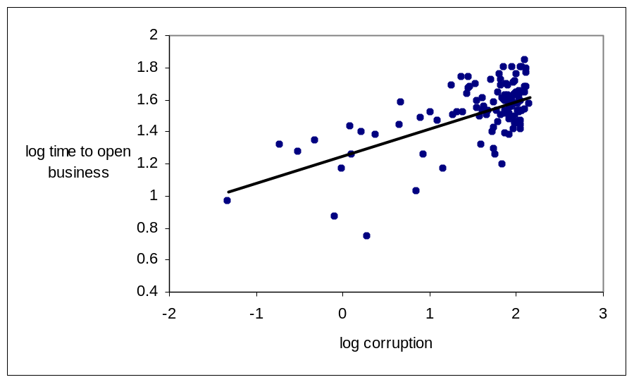

Source: Data on the average time to open a business are from the Doing Business database published by the World Bank (http://www.doingbusiness.org/). The Doing Business database provides measures of business regulations and their enforcement for 155 countries.

Figure 2. Partial Correlations between Quality of Public Infrastructure Projects and Corruption Index
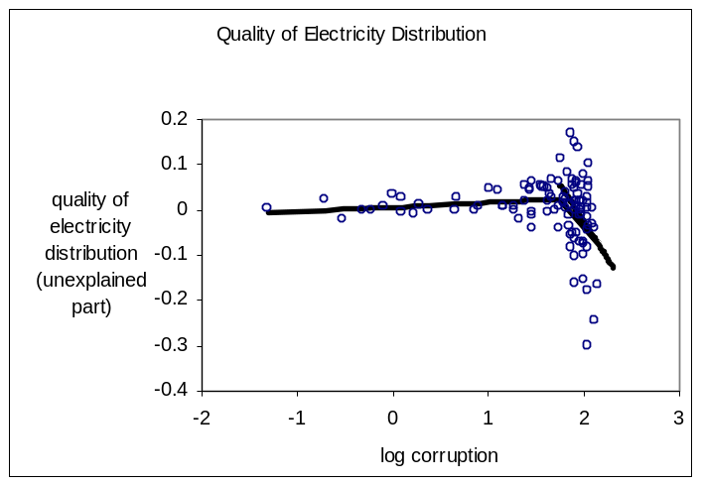
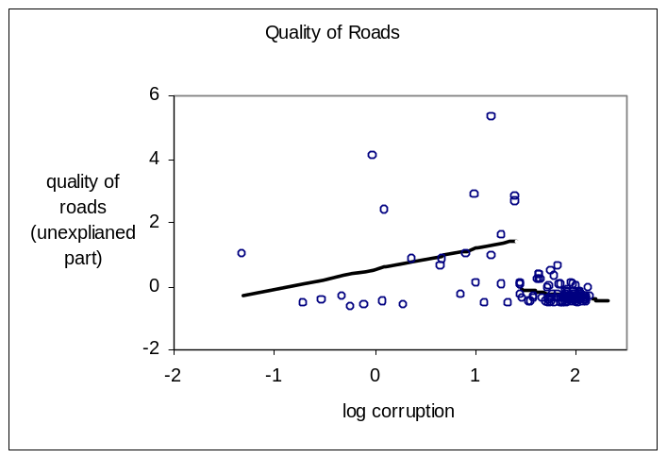
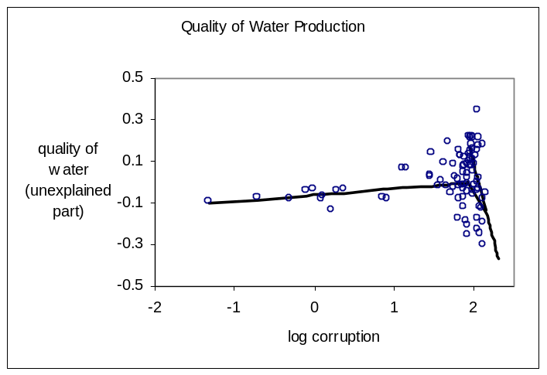

Notes: Partial correlations are based on residuals from a regression of quality variables against log initial GDP estimated without assuming the existence of a threshold.

▪ Corresponding author: Tel.: + 1-414-229-4402; fax: +1-414-229-3860. E-mail addresses: nbose@uwm.edu (Niloy Bose), scapasso@uniparthenope.it (Salvatore Capasso), amurshid@uwm.edu (Antu Panini Murshid)
The term “cancer of corruption” was first used by James D. Wolfensohn in his presidential address at the 1996 World Bank/IMF annual meeting.
To keep the story simple, we have not explicitly modeled the possibility that the government will prosecute and penalize firms that cheat. Without loss of generality however we can simply assume that when illegal activities of a firm are revealed, a penalty is imposed which is proportional to the scale of the operation.
Bardhan (1997) cites an example in which a highly placed public official in New Delhi reportedly told a friend: “if you want me to move a file faster, I am not sure if I can help you; but if you want me to stop a file I can do it immediately.” Bardhan cites the 1964 Santhanam Committee (appointed by the Indian Government) report on the prevention of corruption which notes that corrupt officials actually cause administrative delays in order to attract bribes. In Russia, such activities are commonly referred to as “mzdoimstvo,” which means to remunerate someone for doing what he was supposed to do any way.
could also be thought of as being, on average, a lower quality of service. Thus for instance, if the government is building fewer paved roads as a consequence of corruption within the government bureaucracy, the average quality of roads in a country will decline. Alternatively consider for instance government provision of electricity generation services, a reduction in output could entail more blackouts and power outages and consequently a lower quality of service on average.
Such a specification assumes a discontinuity at the threshold, as such it is more general than a continuous spline function which is continuous at 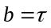. While methods exist for estimating and for approximating the asymptotic distribution of these estimators in either case, the results for discontinuous threshold models do not specialize to the case of continuous linear spline functions (Hansen, 2000; Chan and Tsay, 1998). In fact, the asymptotic distribution of is highly non-standard in the discrete case. Here we model threshold behavior by allowing for discrete jumps between regimes because this case imposes less structure on the model.
This procedure seems to work best. Certainly we can consider alternative choices for the probability distribution of the random error term, . However Davidson and Flachaire (2001) have shown that when is symmetric the simple 1-0 discrete choice suggested by Wu (1986) works well.
This is opposite of the convention of treating higher values as associated with lower levels of corruption.
This view, has for instance, been articulated by James D. Wolfensohn, former World Bank president. “We are determined to root out fraud and corruption wherever they exist…the Bank continues to be a leader in the fight against corruption, and that we’re looking into every allegation we receive related to our work and we are being fully transparent about it.”
See for instance Acemoglu and Verdier (2000).

